**IBM NiceBots! Technical Description**

*Rose Baker and Ricardo Graca*

This technical description will be broken down into two sections. First, the front end Unity C# processes as described by Rose. Second, the back end Javascript server processes as described by Ricardo.

***Front End***

For the front end description I will use the following key: scripts, variables, functions, structs/classes, Unity gameobjects/methods, statements/loops. This section is divided into four subheadings for the sake of organisation. A few scripts are ignored as they are simply for debugging purposes.

***First Load***

*TwitterIDEnter, QuizQuestions, RainbowColor, DataHandling, Structs.*

When the user loads the app, the script they activate first is TwitterIDEnter. In its Start() function the script sets the scene to show its ‘normal’ phase by setting certain gameObjects to true or false. The Send() function is called when the user presses the ‘send’ button, and runs the TwitterCheck() function. This gets a string from the input field and first checks if its empty. If it is it displays an error to the user, if not it sets the API.username as the string and then changes to scene to the ‘authorisation’ phase. This then sets SendData’s authorisation to true to send an authorisation request, which I will explain more later, and runs the Authorisation() function.

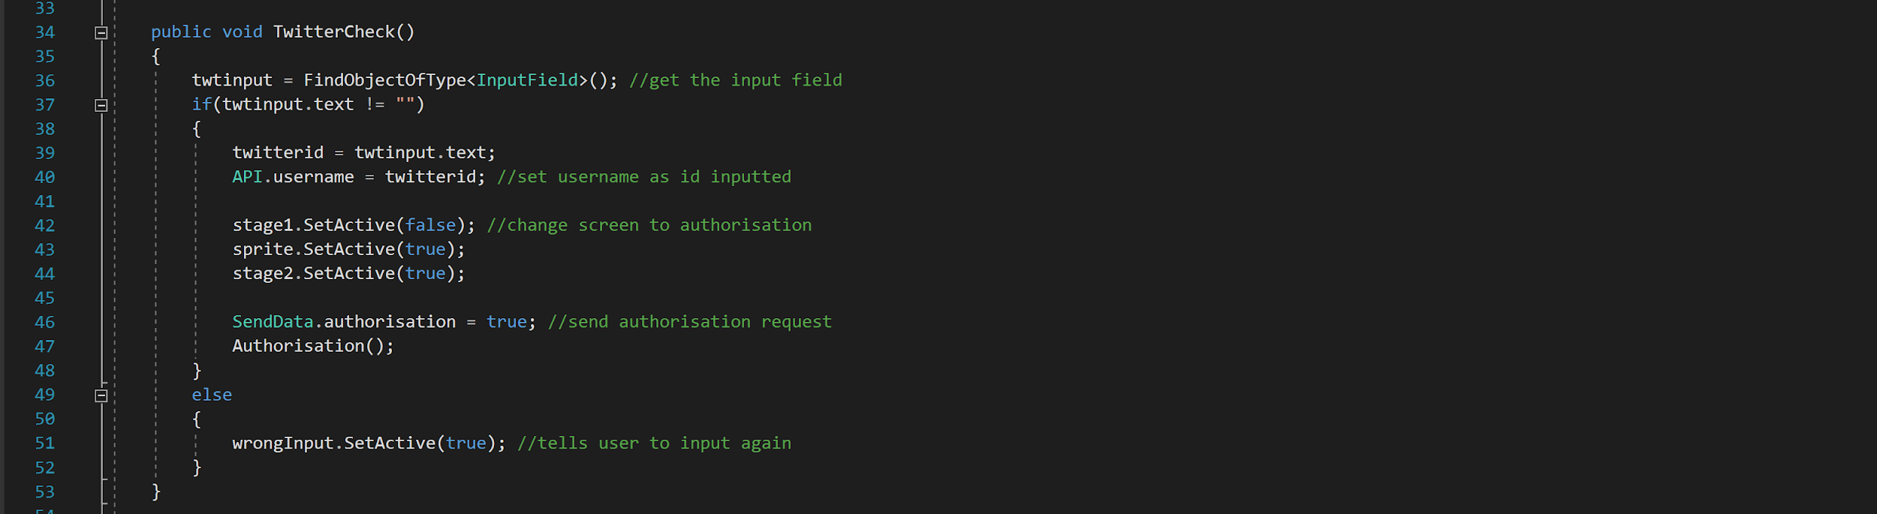

Authorisation() runs the Contact() function contacts the DataHandling script and sets its authorisation bool to true, causing it to run the getData() function. I’ll explain what happens here later. Contact() gets the response from DataHandling in the array data and checks to see if the first char is ‘1’, if it is it means the user is authorised and can proceed, authorisation is set to true.

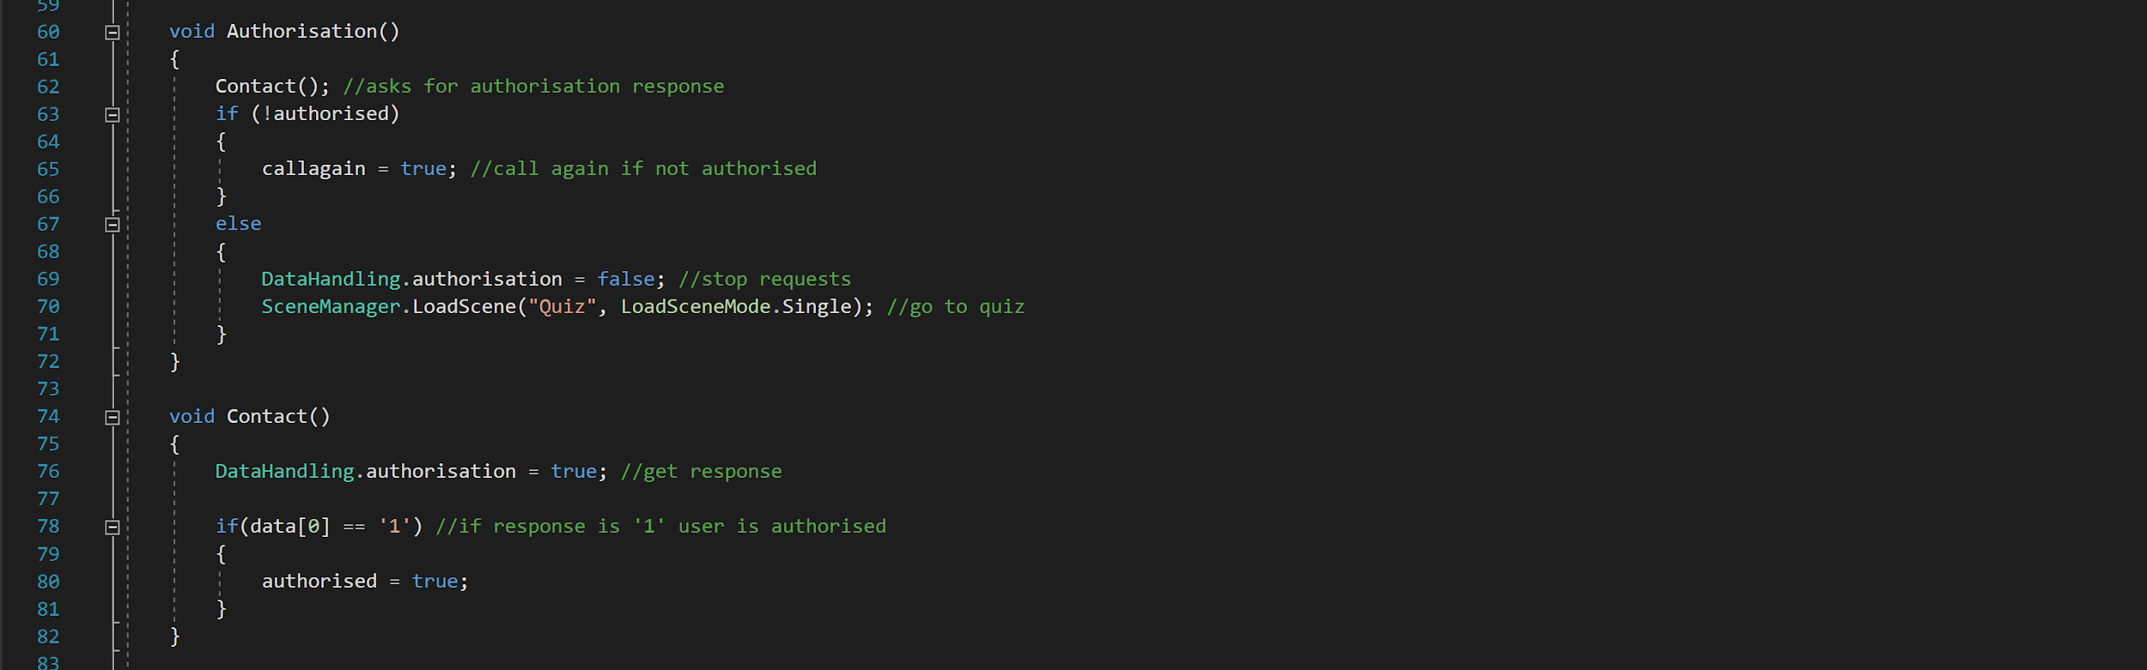

Authorisation() then checks to see if authorisation is true. If it’s not, the callagain bool is set true, if it is DataHandling’s authorisation bool is set to false to stop the requests and SceneManager changes the scene to the quiz.

When callagain is set to true the Update() function will run the if statement at line 27. The bool is instantly set to false again and the CallAgain() function is run. This runs a coroutine with the SendRequest() function to wait for five seconds and call Authorisation() again.

You’ll see this method of running functions using bools and if statements in the Update() function used a lot in my code. I found it was the easiest way to start non static functions using a static function and a static bool, because you cannot simply call it. This method also works as you can call the static bool from other scripts and run the non static function directly.

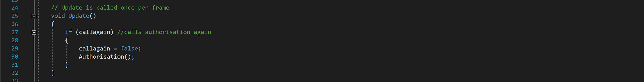

The next script to run is QuizQuestions, which handles the questionnaire section. The point of this script is to show all of the quiz questions and record their answers. At the start of the script a lot of arrays are initialised, which may seem inefficient but after a lot of trial and error proved the easiest way of storing data for this section.

When the user presses the ‘begin’ button the StartQuiz() function runs and changes the gameObjects active in the scene, then runs the ShowQuestion() function. ShowQuestion() puts all of the Q(numb) strings into an array called questions and sets the counter to the number count + 1 to show the user what question they’re on.

If end is not true (it’s not the end of the quiz) a flag is used in a while loop to find a random question between 1 and 24, and then finds the corresponding value in the answered array. If this value is not ‘1’ then the question is not answered then it is set as the current question. The count is increased, the flag set to false to break the while and the answered value is set to ‘1’. This method means the questions will be displayed in a random order each time.

If end is true the gameObjects in the scene are changed to show the ending screen and the Sort() function is run with the questions array passed through. The end is made true if the Update() sees that count is over 23.

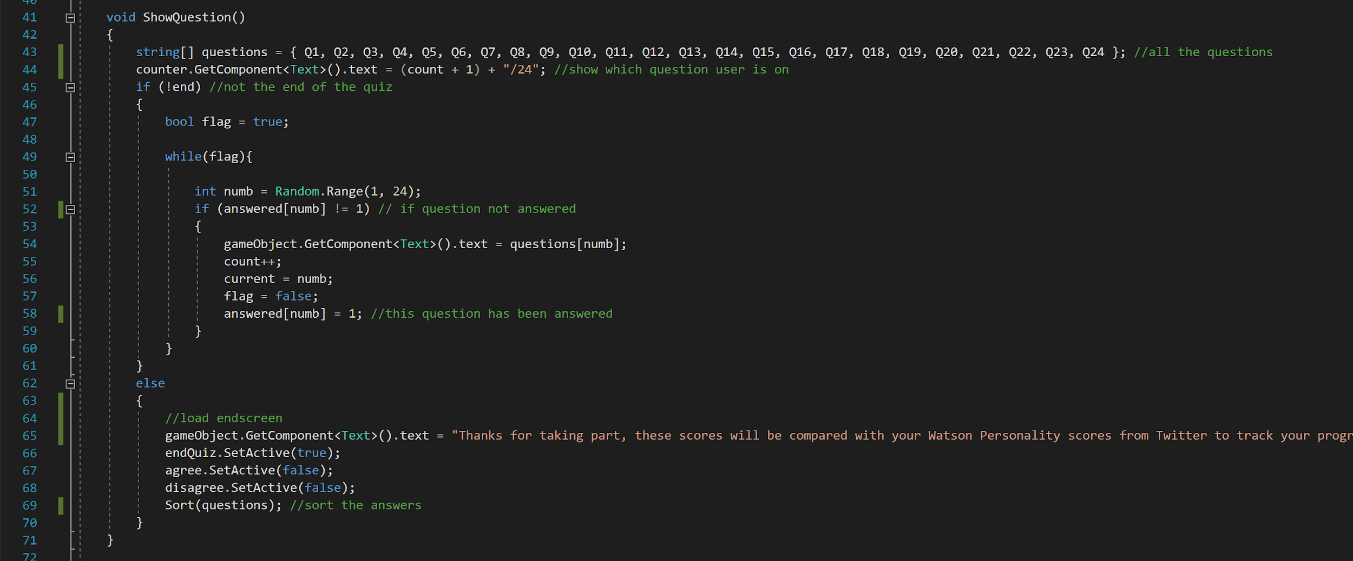

The user pressing the ‘agree’ or ‘’disagree’ buttons calls the Agree() and Disagree() functions respectively. These set the current question’s answer value to either true or false and then runs the ShowQuestion() function to move to the next function. The ‘finish’ button moves the scene to ‘AllScenes’ with SceneMaganger.

The Sort() function contains a for loop to go through all the questions, check the type of them and then use a switch statement to tally up, if the questions corresponding answer is true, the values of emScore/extraScore/openScore/concScore/agreeScore. These final int values are then put into an array and a for loop runs again with a switch statement to assign each of the array values to the Ideals values with a small calculation to make them all equal. These are then put into another array to be passed into the UserProgress script to be used later, and passing into the SendData script to be sent to the server.

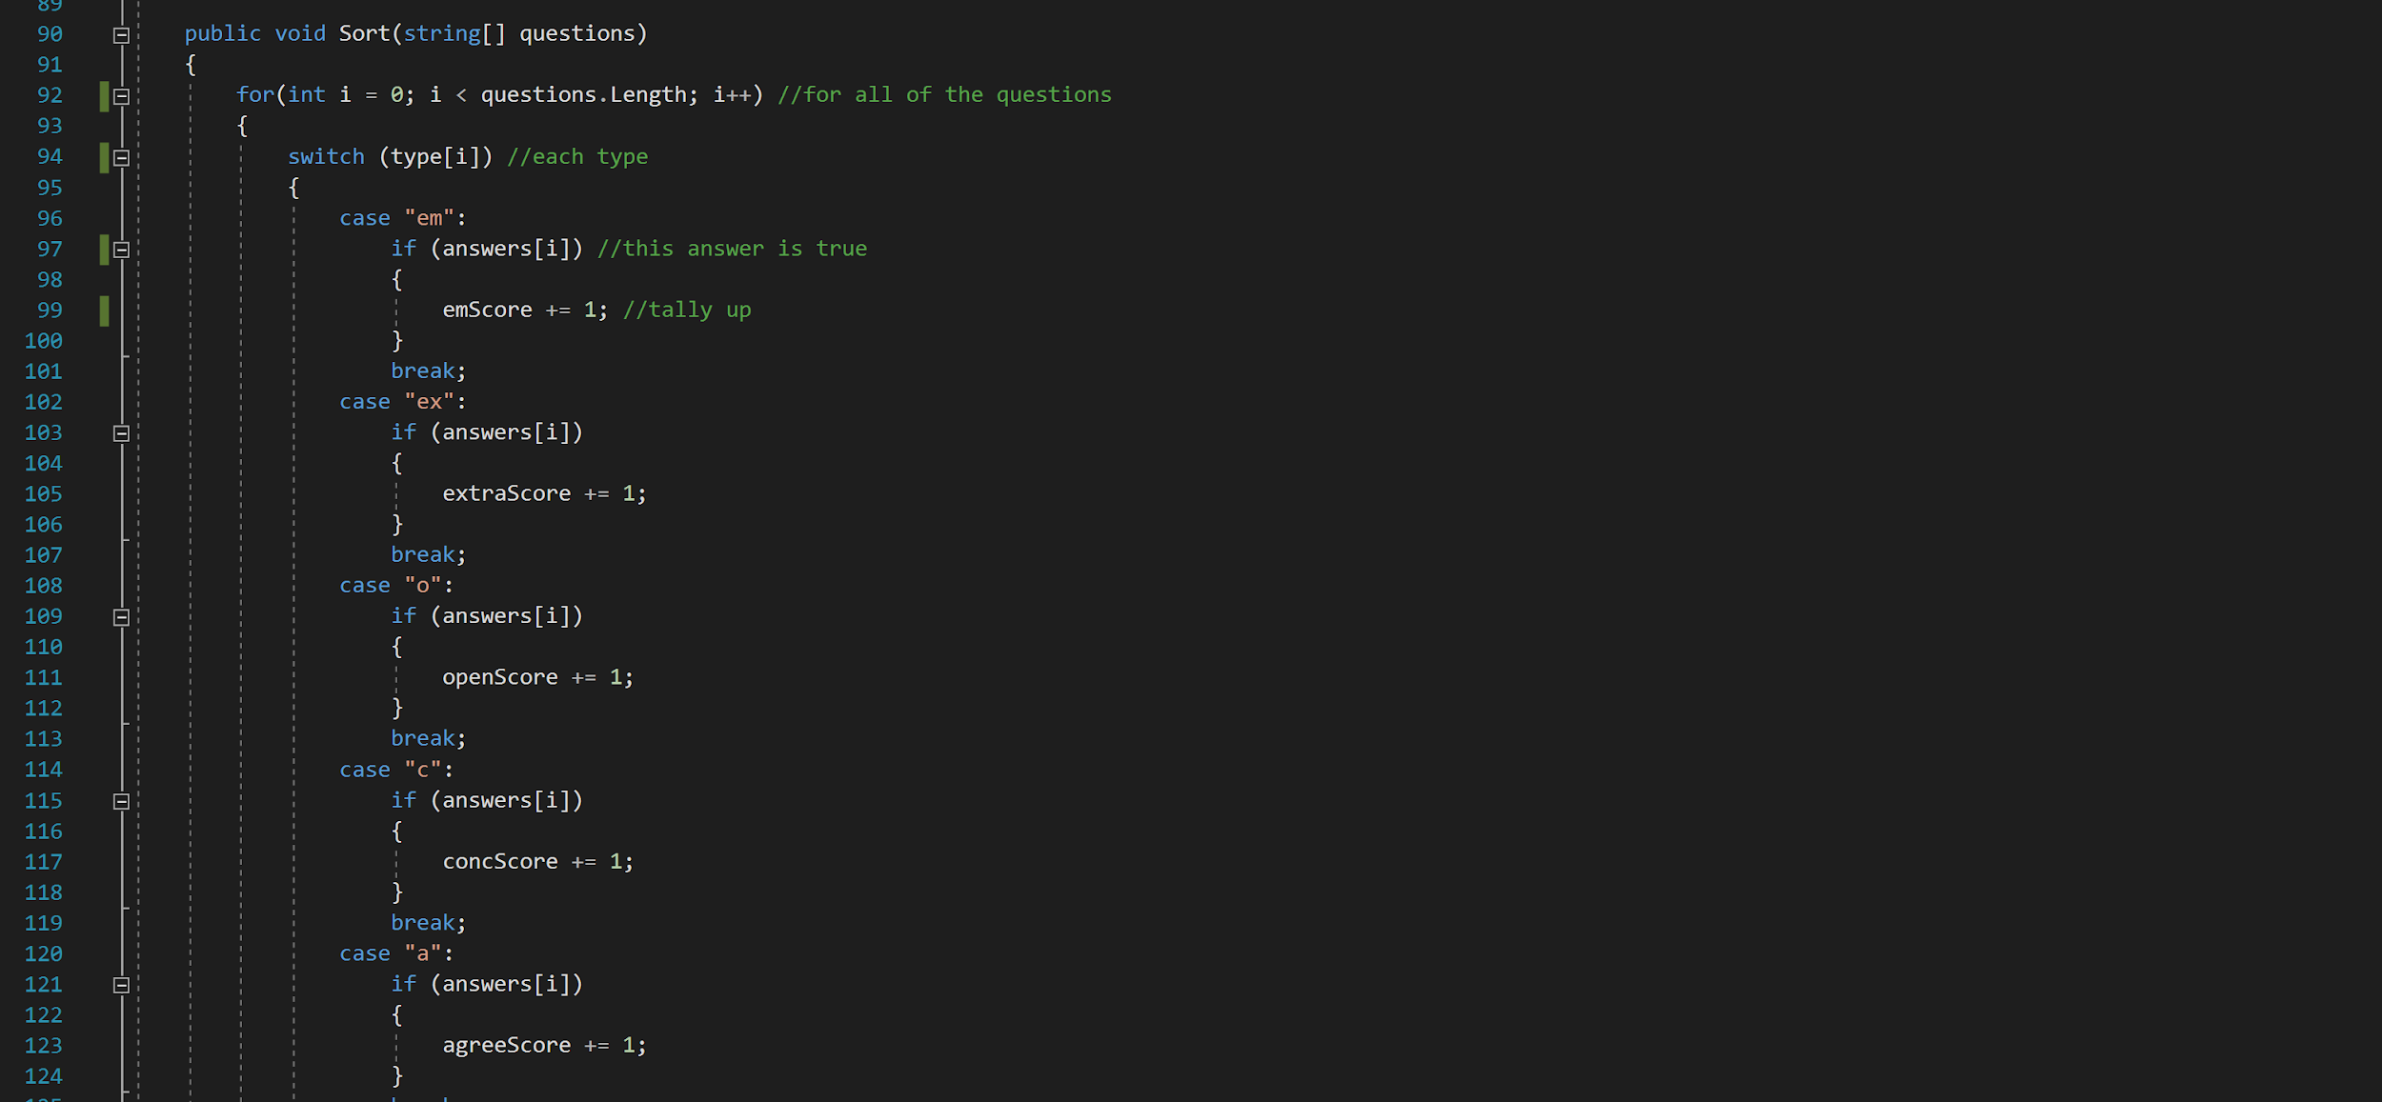

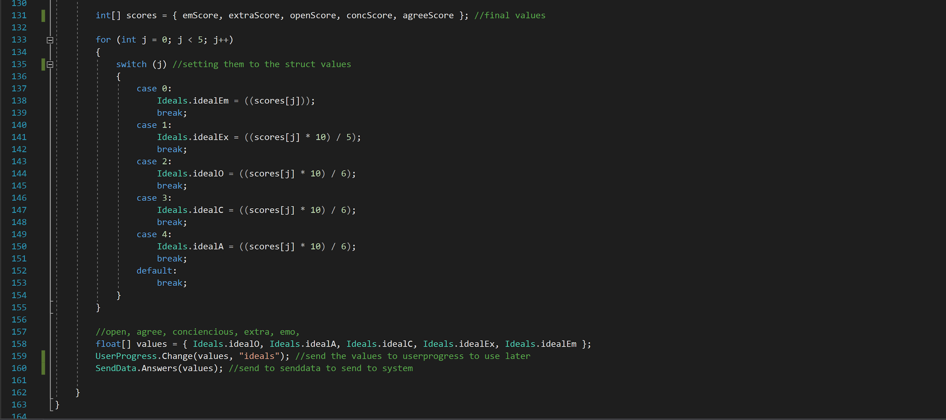

Alongside this script runs the RainbowColor script. This is a simple script to change the color of the image object over the background, it only runs the Update() function. It uses a switch statement to cycle through six ‘stages’ of the rainbow, decreasing or increasing the r/g/b value of the current color until it reaches a certain boundary, and then moving onto the next stage. It’s fairly simple.

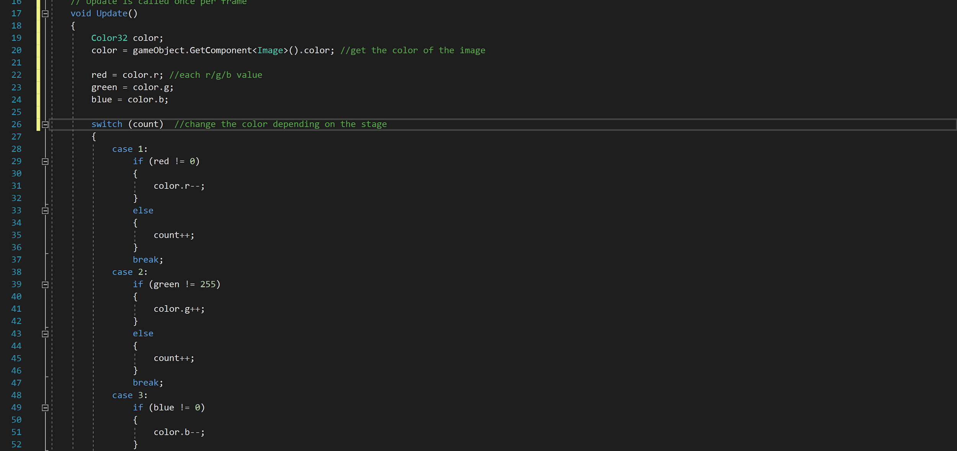

Now I can explain the DataHandling, SendData and Structs scripts. These three are the key scripts for the program to run, and handle the functions of sending, retrieving and storing data.

First, the DataHandling script. This script handles all of the requests to retrieve data from the server and sorts it into useable lists and variables, or sends it to be sorted elsewhere. The getData() function is called whenever the program wants to receive information, and starts a coroutine with the function GetData(). This is where the WWW requests are made depending on what bools are true. For example if the authorisation bool is true then the program sends an authorisation request. This is done using WWW and a yield return with the WWW. This returns the result in a string format which is sent to be sorted. This is similar for each of the functions so I won’t explain all of them.

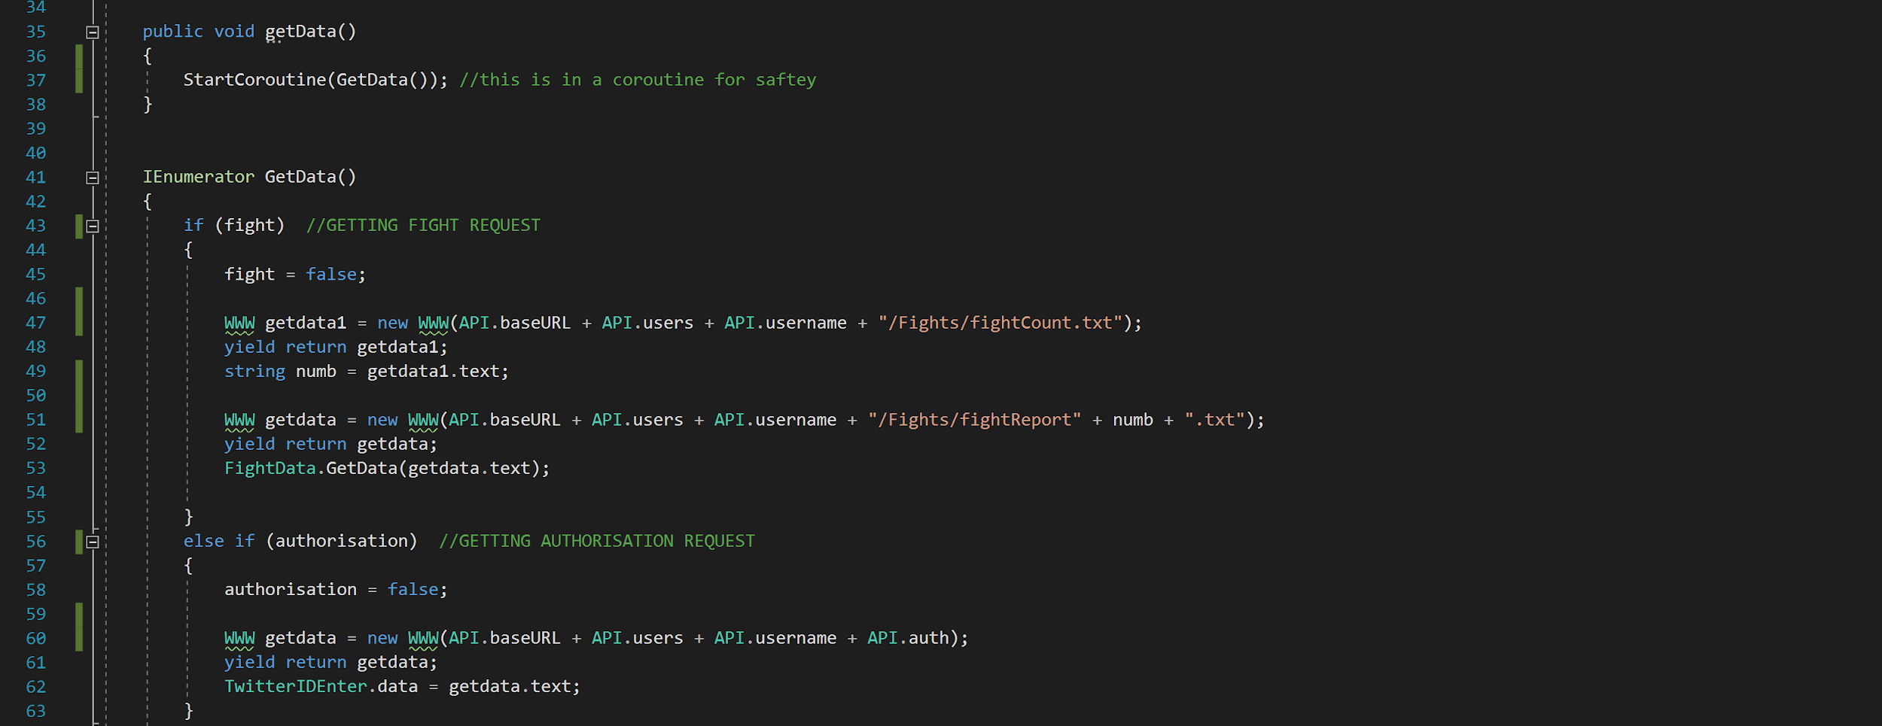

The SortData() function in this script is only for the users data. It uses a for loop to go through all the chars in the data string and detect which ones are values by seeing if it’s not a space, it then assigns these values to each value in the Data struct to record the users information. This data is then sent to the UserProgress script.

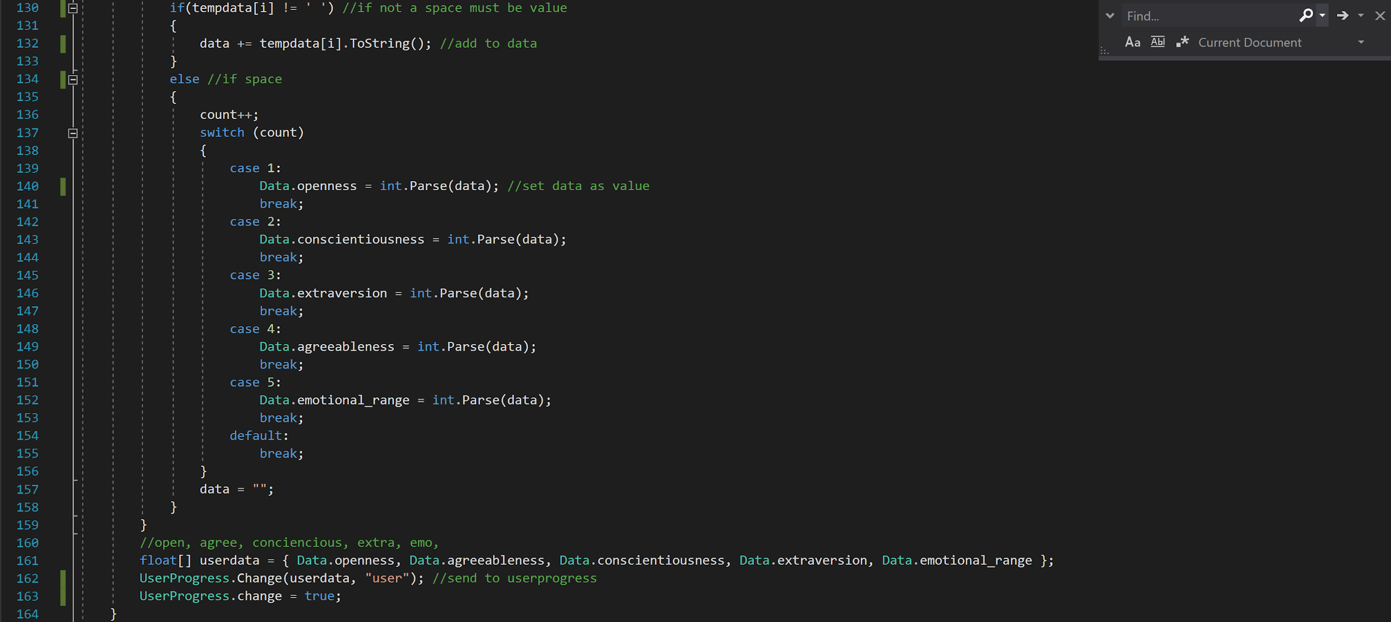

The SortModuleData() function is used for each of the modules loaded. This functions similarly to SortData() but checks for ‘/’ instead of ‘ ‘. Each of the modules sorted information is pushed into a List called moduleList to be used later.

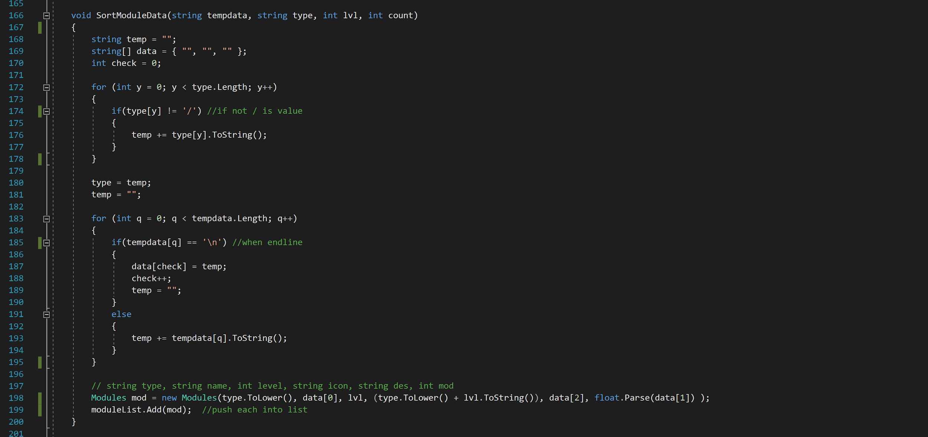

SortRobotData() follows the same format, but uses a switch statement to assign the name and level of each of the modules currently equipped to the robot with the Robot struct.

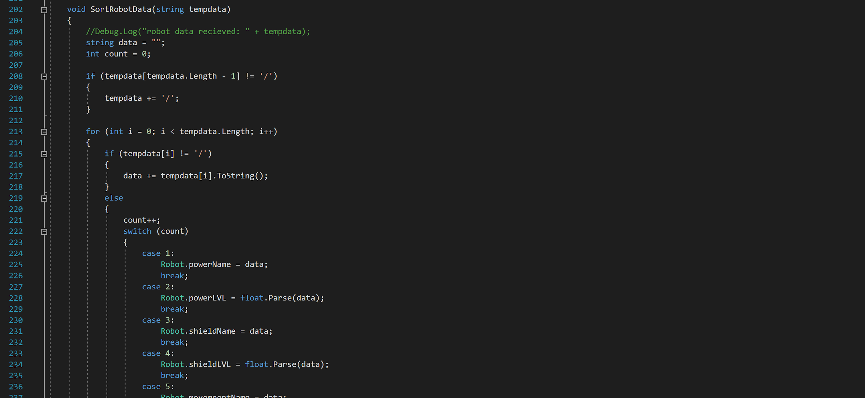

The SendData script functions similarly to DataHandling as it uses the WWW method to make requests to the server, but doesn’t use the return. This is so the server can see the request has been made and take the request string and turn that into data. So the key here is not the data being returned but what is actually important is the request string.

The static functions are called with different information passed through to be sent. Using Answers() as an example, we can see the string of the questionnaire data being passed through. This is first formatted by being pushed into a List called answerData. The sendQuestions bool is set to true to run the sendData() function that starts the coroutine with Send().

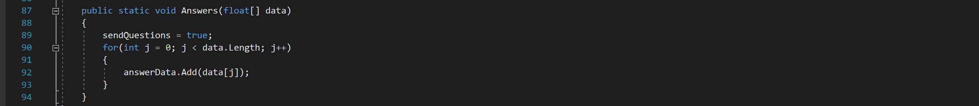

Because sendQuestions is true, a for loop cycles through all of the values in answerData and adds each of them to a tempdata string, separated with a ‘~’ so the server can parse them. This tempdata string is then sent as a server request.

In the sendRobot part of this a for loop is used to cycle through all of the modules in moduleList, checking the name of each module against the name of the one being equipped. If they match the request sent is this module’s type and level.

Each request is built using the API struct values as syntax.

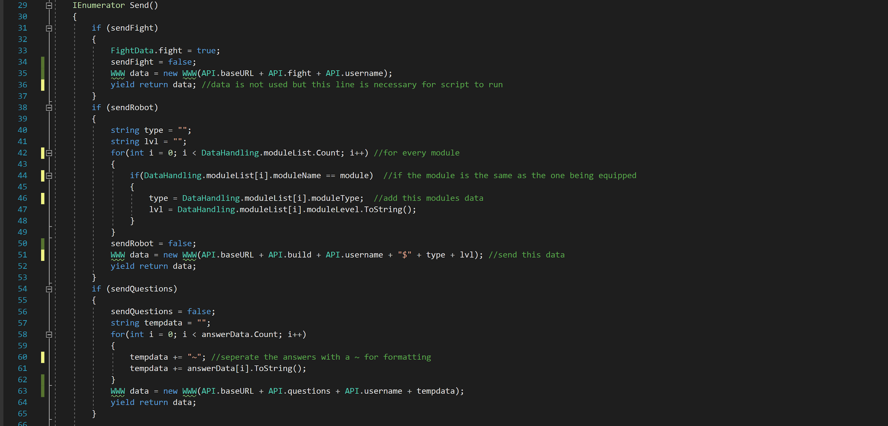

The Structs script is where most of the data is stored. It contains four structs and two classes. The Modules and FightSequence classes contain constructors to set the values for each instance of the class, which are stored in a List elsewhere. The API struct is where the ‘syntax’ for sending WWW requests is stored, as it can be easily changed and added to from here.

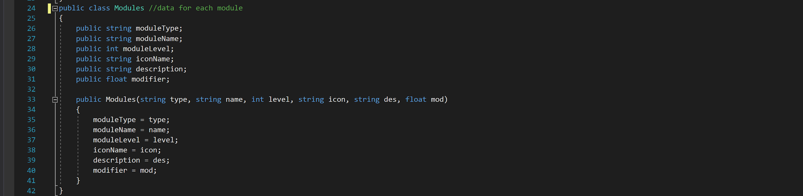

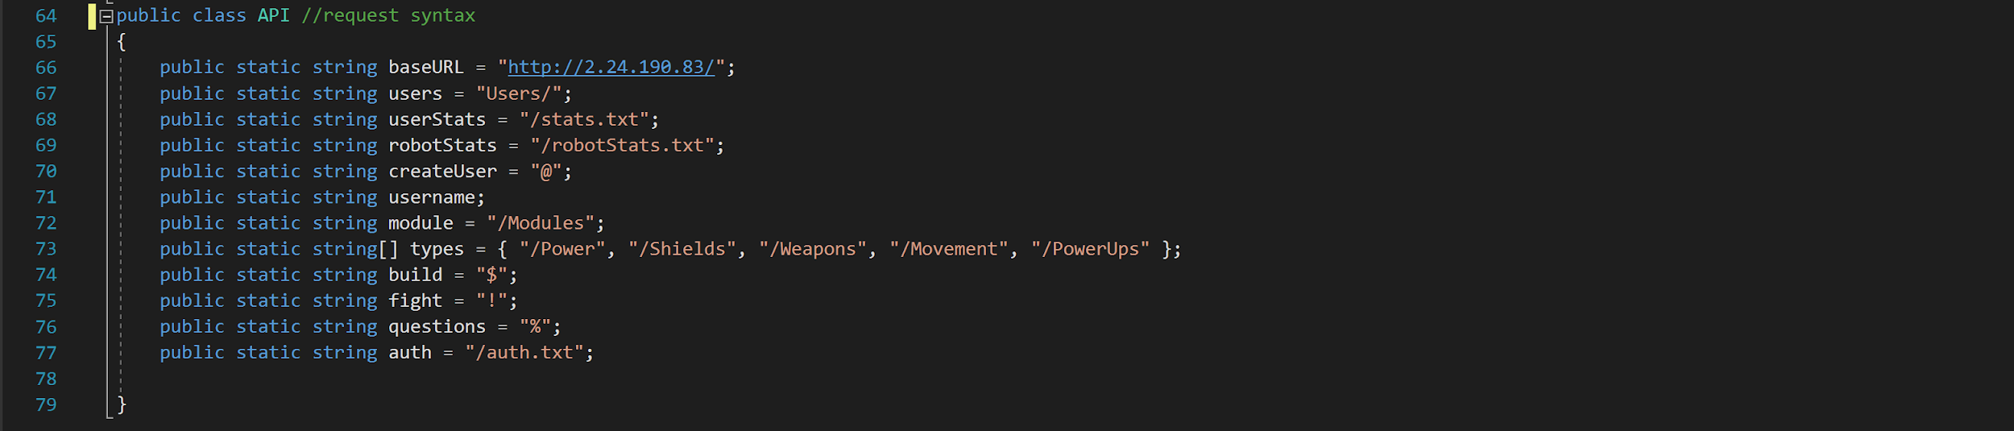

***Display Screen***

*UserProgress, RobotInfo, RobotBars, ModuleLoad, ChangeScene, CanvasMove, MoveCube.*

These are the scripts that run when the ‘AllScenes’ is first loaded, and are used to change the information on screen or the canvas itself.

UserProgress is the only script that affects the ‘progress’ screen. The Change() function is called by either the DataHandling script or the QuizQuestions script and takes an array of data and a string to indicate which type of data it is. A for loop is used to add this data to either userdata or idealdata depending on the type.

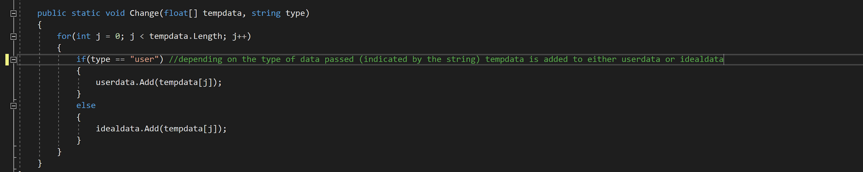

The change bool is also changed from other scripts and puts both the idealdata and userdata into another List called data. It then runs the ChangeScreen() and ChangeData() functions. ChangeData() takes all of the gameObjects and puts them into an array called bars, it then sets the y size delta of these gameObjects to each of the values in the data list times by 8 for scaling.

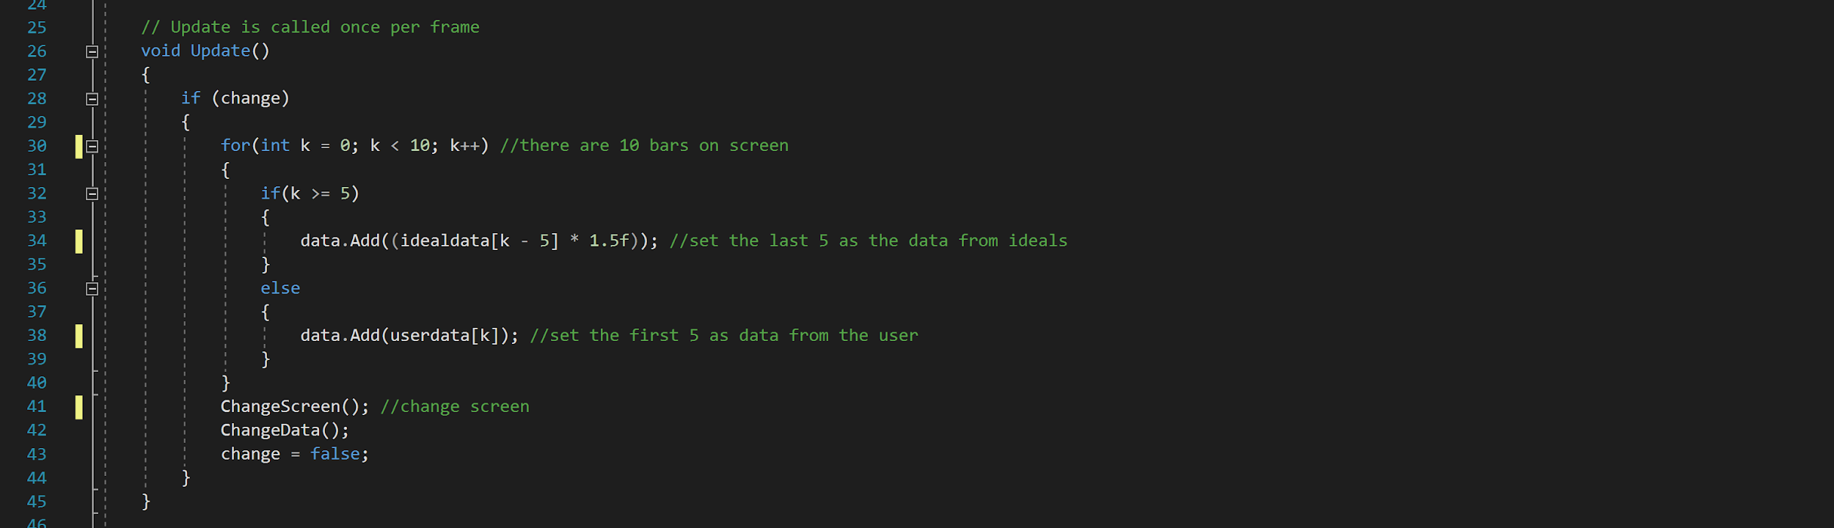

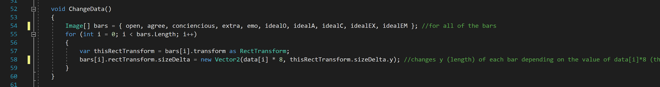

RobotBars is a script that uses this method also, but displays information about the users data on the ‘main’ screen by accessing the Robot struct values.

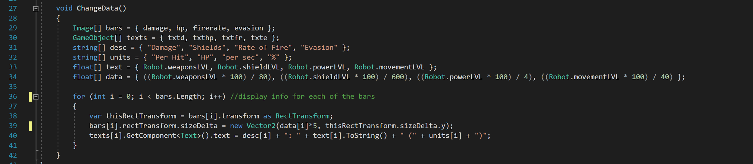

RobotInfo does the same thing again, but this time adds in the mod value from the instance of the moduleList passed into it through the ChangeBars() function. It finds this by looping through the names of all the modules in moduleList and finding the matching one. It uses a switch statement to set this modifier to the correct pMod/sMod ect depending on the type. Then it changes the size of each bars current values and new values if the module would be selected with some calculations to make them all look equal. This is updated every time the user selects a new module to look at.

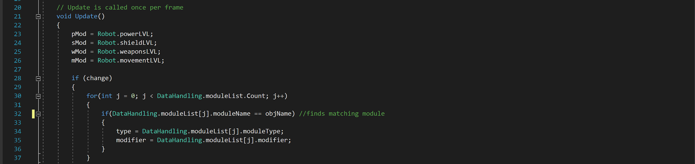

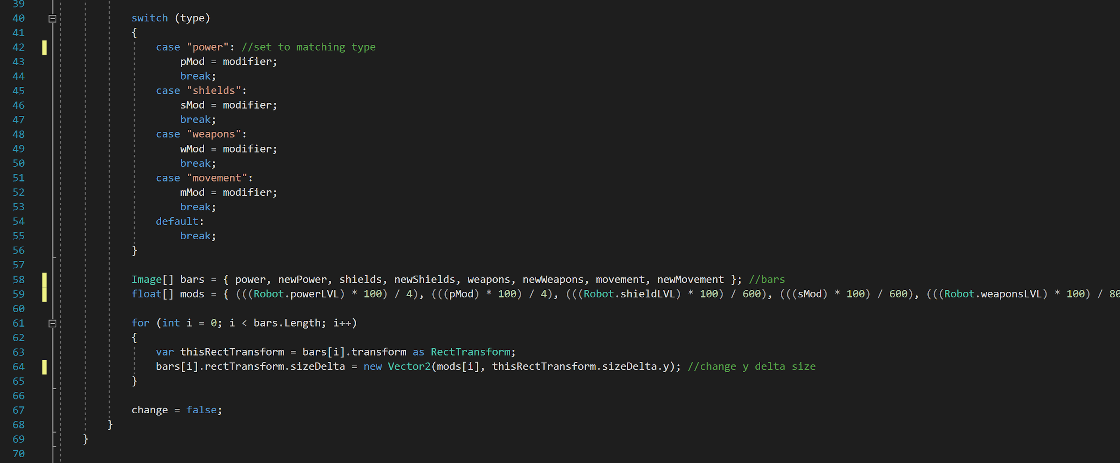

ModuleLoad is a script attached to the content section of five scroll views that loads in modules using a for loop that cycles through all of the moduleList. A gameObject is instantiated from a prefab that has each module’s details attached to it, including the specific texture loaded from the resources folder using Resources.Load(). The ModuleChoose script is also added to each gameObject.

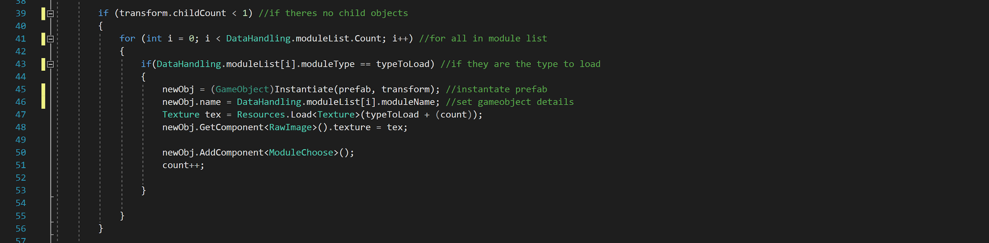

ChangeScene is a simple script that’s called whenever each of the tab bar buttons are pressed. It sets the clicked button to selected to change the colours and runs the Change() function from the CanvasMove script with a string to indicate the selected change.

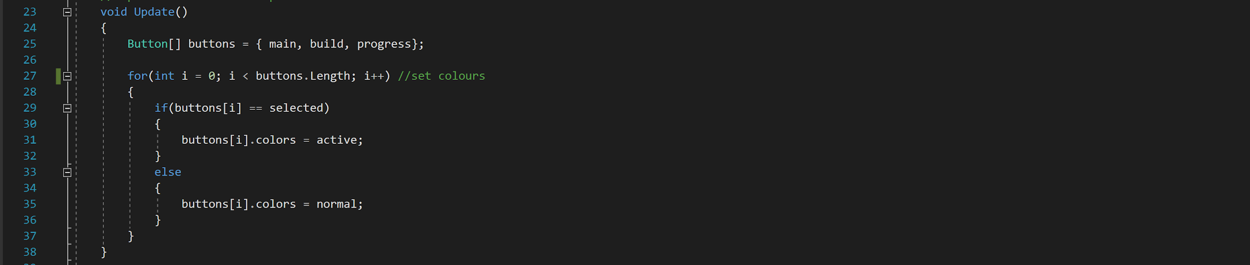

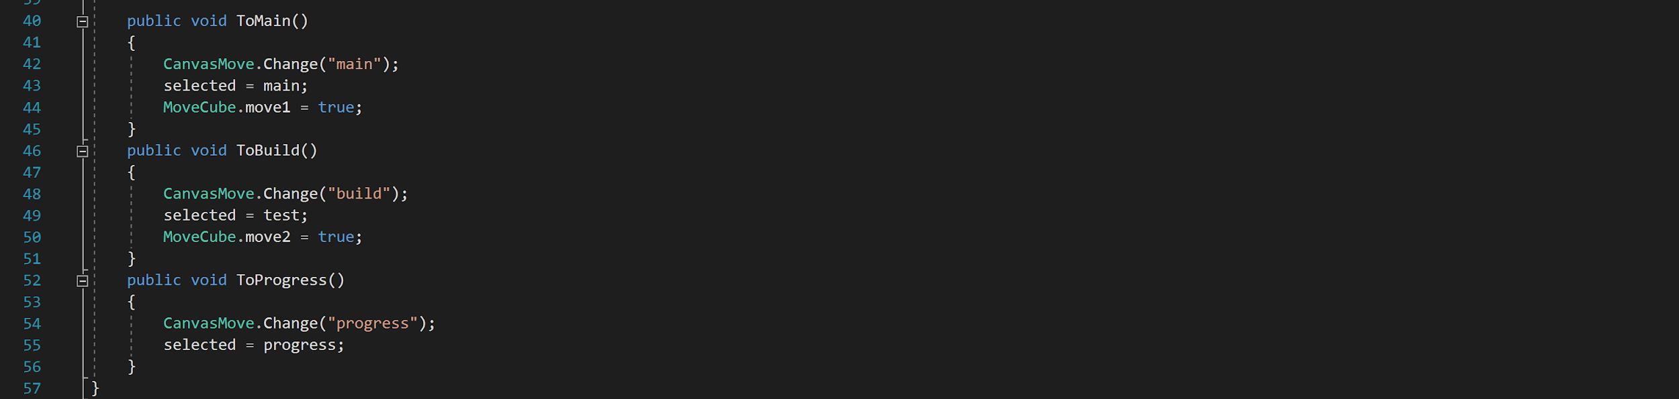

The CanvasMove script is pretty self explanatory. It takes the ‘selected’ string from ChangeScene and then moves the three canvases accordingly by adjusting their rectTransforms. It also deactivates the cube if the ‘progress’ screen is selected.

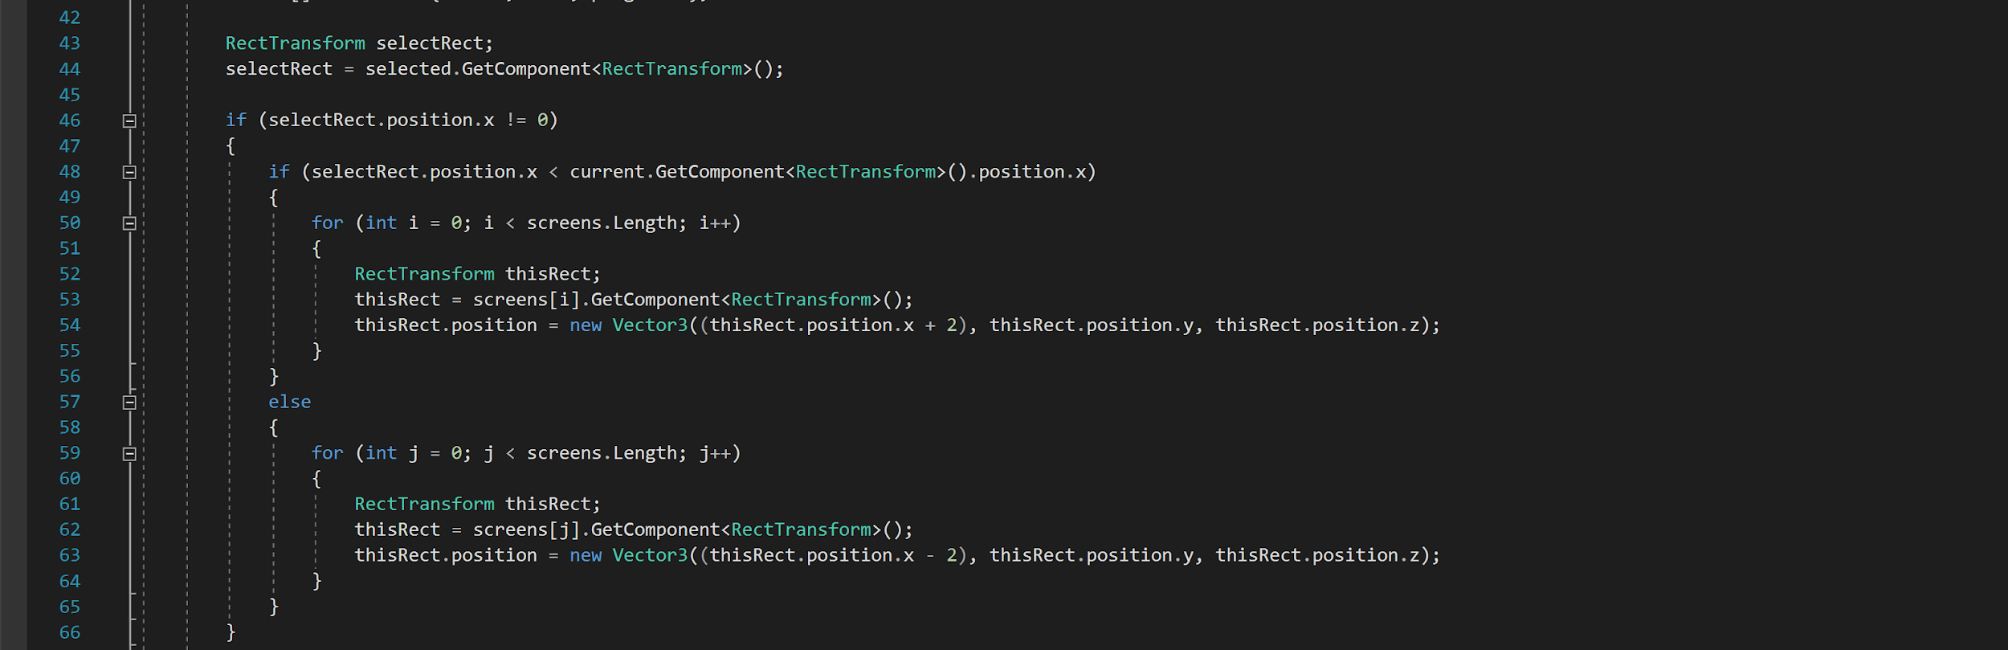

MoveCube is another simple script that accesses the Animator to run animations to move the cube on screen if the ‘build’ or ‘main’ screens are selected. This works by changing the Animator bools to true or false and which play animations if they are true.

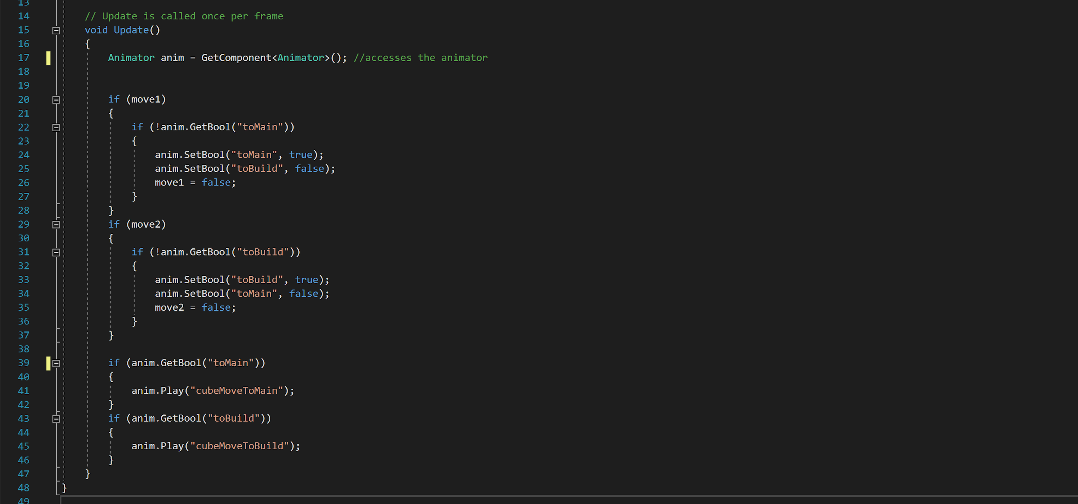

***Equipping Modules***

*IconClick, ChangeTab, ModuleChoose, ModuleDescription, ModuleEquip.*

This section is for when the user uses the ‘build’ screen. It includes handling the module data and displaying it to the screen.

IconClick is a very simple script attached to each of the icons that tells the RobotInfo script to update and the ChangeTab script what icon is being selected, this changes the scroll view displayed.

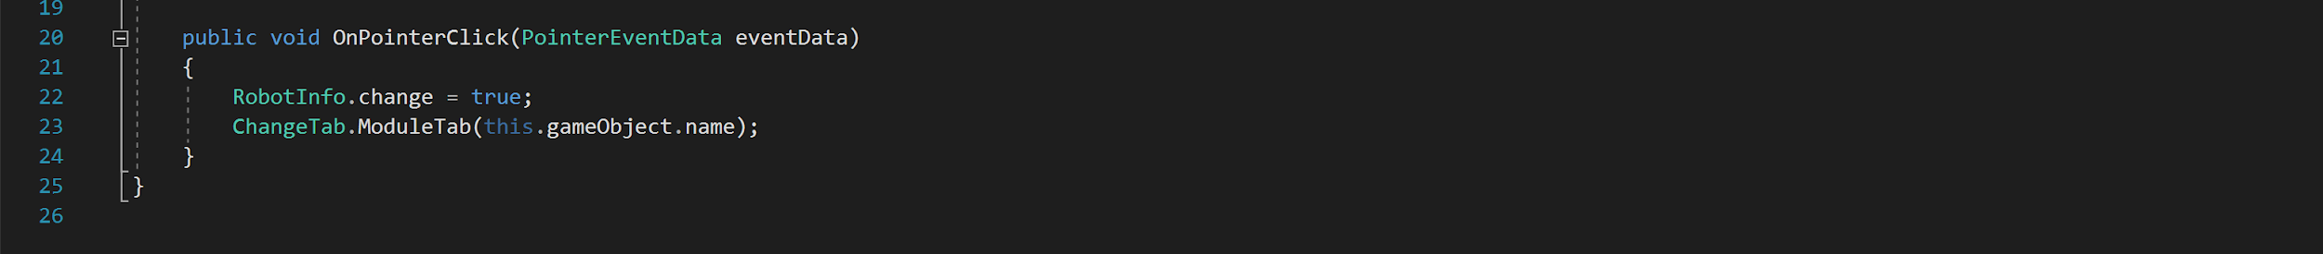

ChangeTab changes cycles through all of the scroll views in an array using a for loop and sets them to active or inactive depending on which value is passed from IconClick. It also changes the color of the icons to white if not selected.

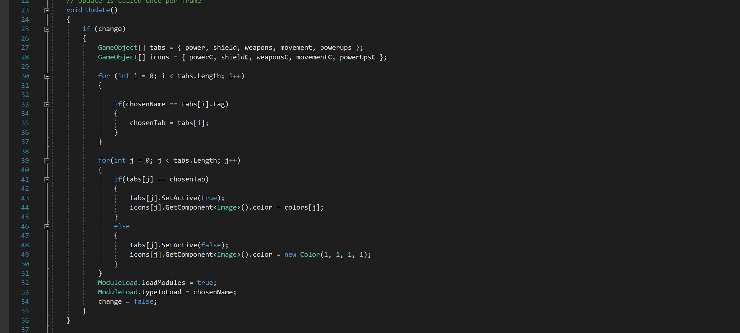

ModuleChoose is attached to each of the module gameObjects and runs other functions in other scripts whenever a module is pressed, sending off that module’s name as data.

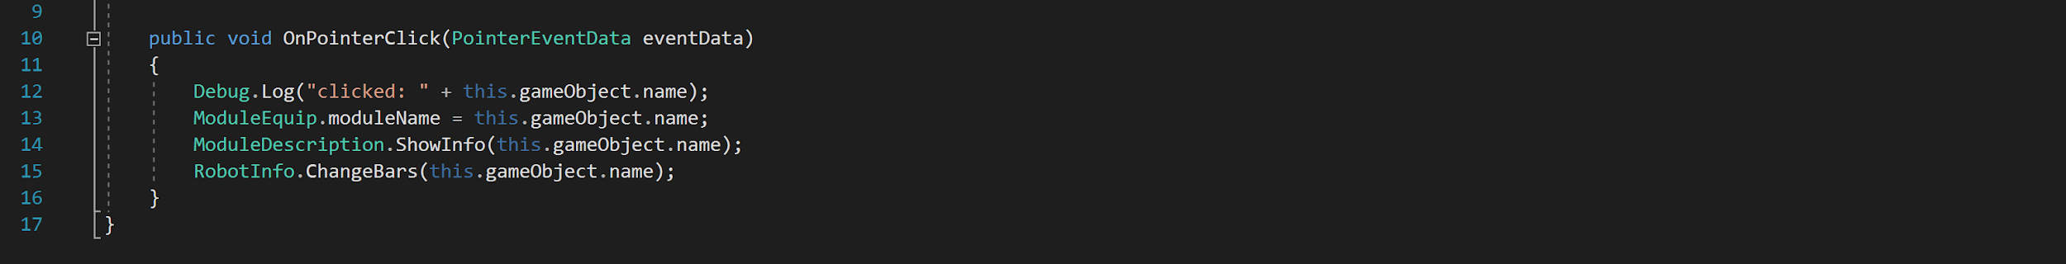

ModuleDescription’s ShowInfo() function takes the string passed from ModuleChoose and displays the corresponding module information by instantiating a prefab the first time and then just changing the data after that. It uses a for loop to check if the passed name matches an entry in moduleList to find the values.

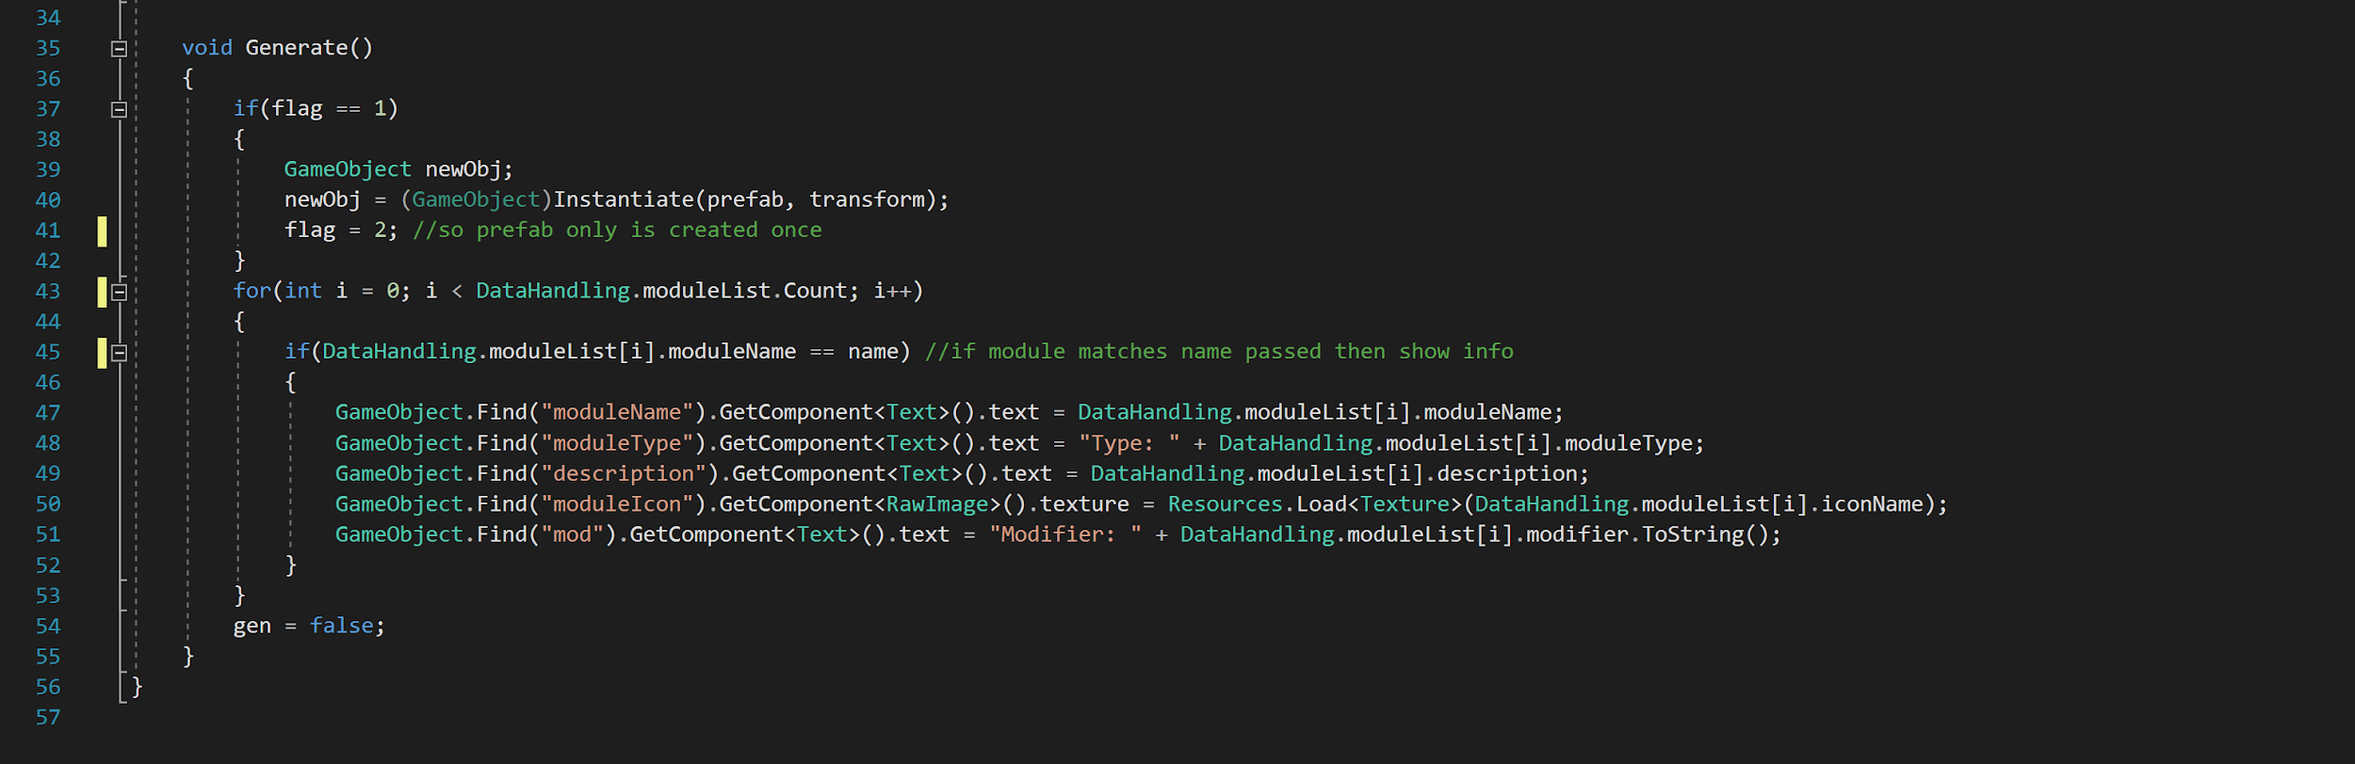

ModuleEquip has an Equip() function whenever the user presses the ‘equip’ button. It’s string moduleName is changed in ModuleChoose and is used to find the information by comparing it against the modules in moduleList in a for loop. Then a switch statement is run to check the moduleList Module mod value against the Robot name for each type, to check if the module is already equipped. If not then it is equipped by changing the Robot value to be this mod value. SendData.Equip() is then called with the moduleName to send this data to the server.

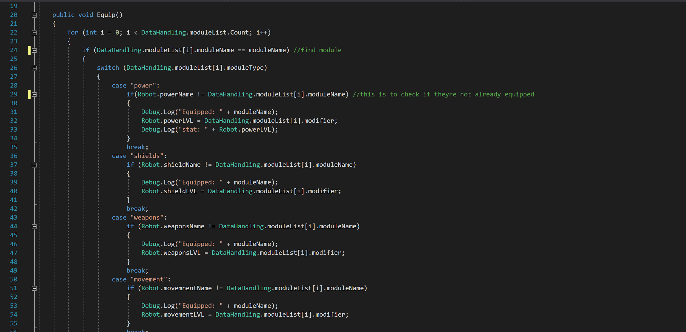

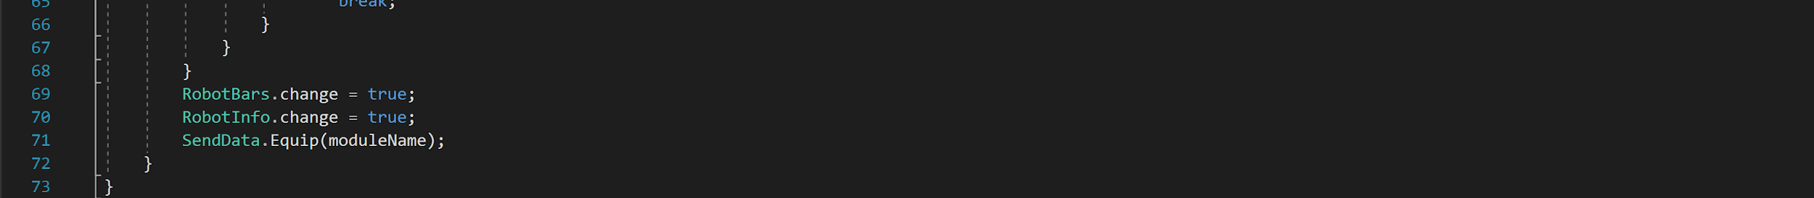

***Fight System***

*FightData, FightActions, Player1Health, Player2Health, Projectile.*

This section covers how the fighting system operates, which is activated whenever the user presses the ‘fight’ button on the ‘main’ screen.

The FightData script handles most of the action, and is the first thing called when the ‘fight’ button is pressed from the SendData script. Firstly it moves the canvases to display the ‘fight’ screen by adjusting the rectTransforms of each canvas. These are then moved back once the fight is over. Once the canvases are moved it starts the coroutine for FightRequest().

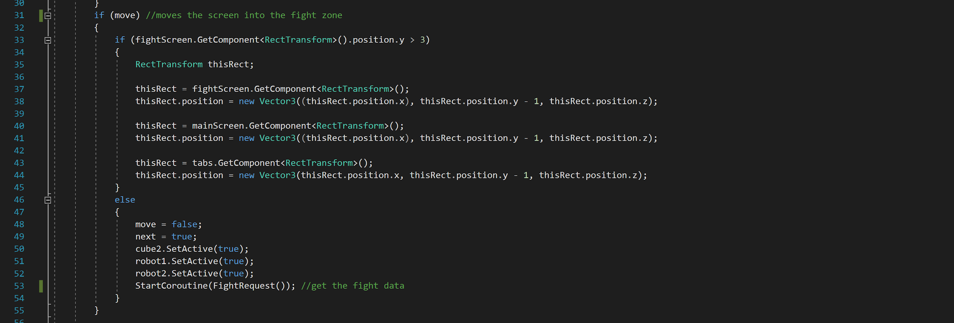

SendData will have already sent a request for the fighting file to be created, so the coroutine waits 1 second before asking for it again. This repeats until the got bool is set to true by the GetData() function, which is called by the SendData script. Once got is true the SortData() function is called to parse the script.

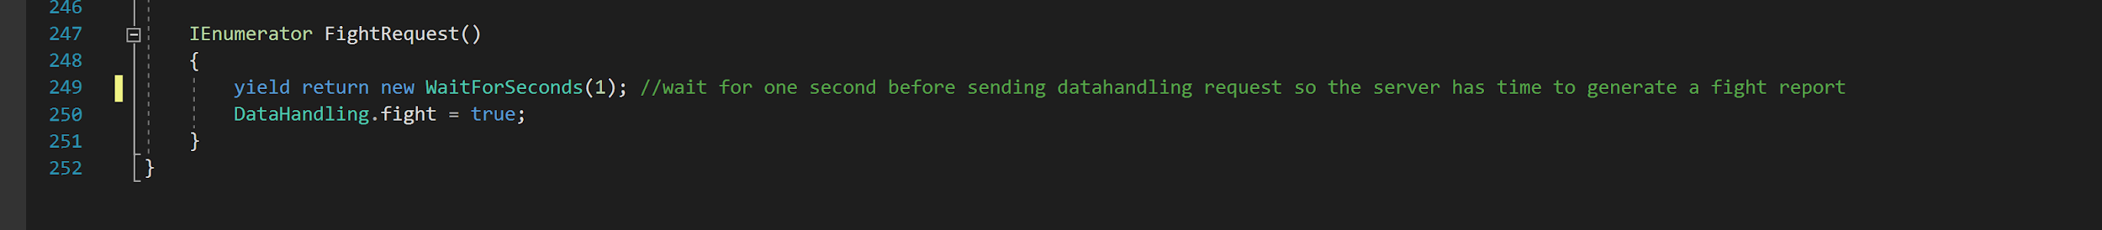

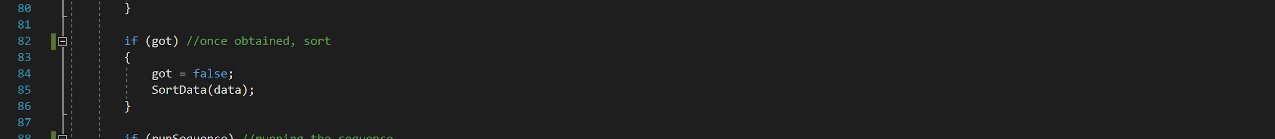

The parse system works by first sorting the full script into lines, as they will be separated by ‘/n’, and pushing them into a List called actions. It then runs through every char in lines of the actions List and formats them into a sequence string, which will be a word. If the word is dealing or dmg it is ignored, and the sequence string goes into a switch statement. Depending on the count the word is checked differently, and attributed to a value. Case 3 is ignored because it’ll be a second username, which is useless but cannot be ignored by the program as there is no way of telling what it’ll be. If the sequence word is ‘wins’ the current attacker is set as the winner.

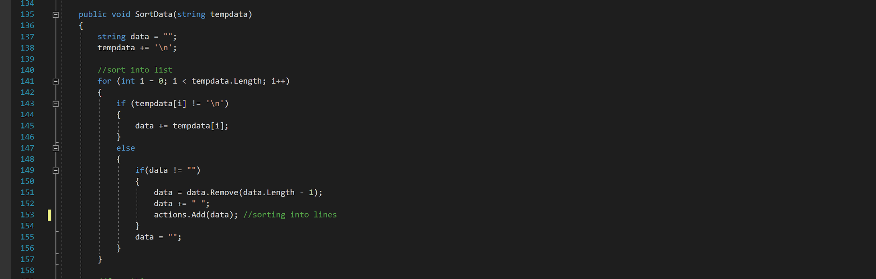

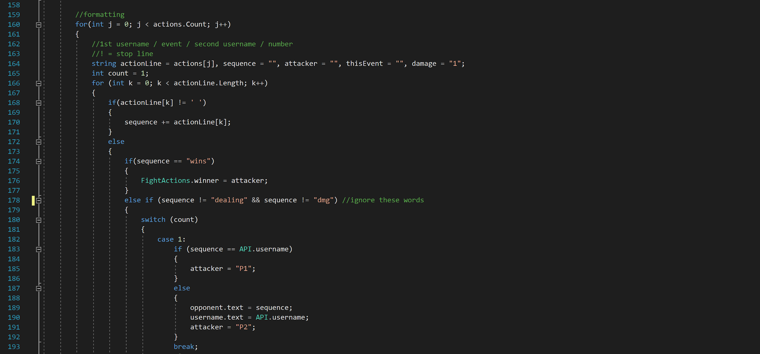

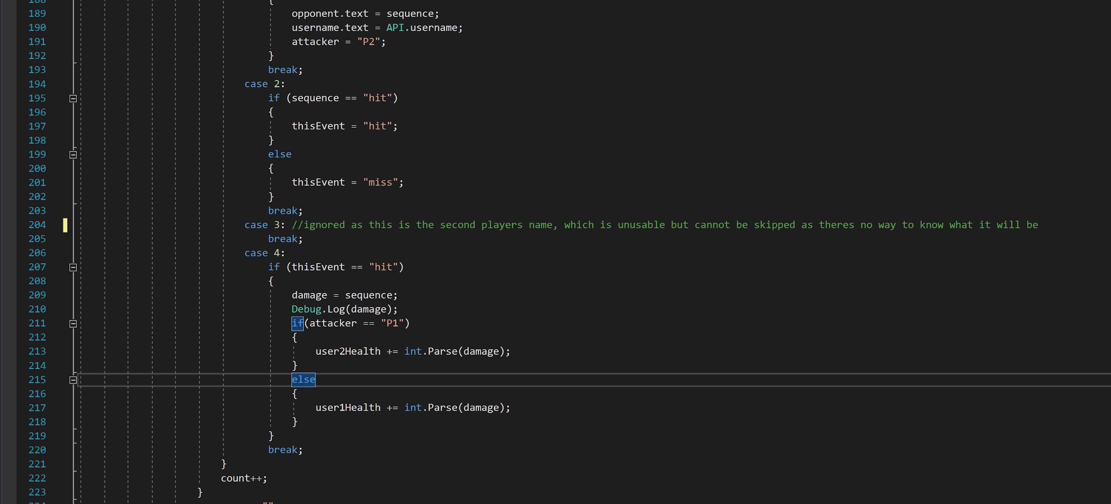

After each line the processed data is pushed into a List called events, and runsequence is set to true to start displaying these events. Then the actions List is cleared for the next fight.

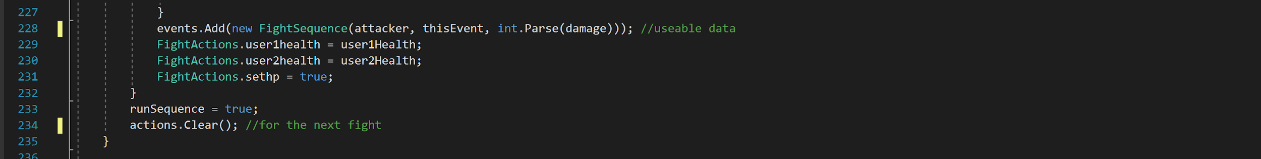

When runsequence is true a count is used to check if the instance is within the amount of events, if not the events are all played and the fight is over. Next is a bool used to trigger the next event in the sequence, as if it just ran it would be ridiculously fast. The event in the events List is checked and different functions are run depending on it.

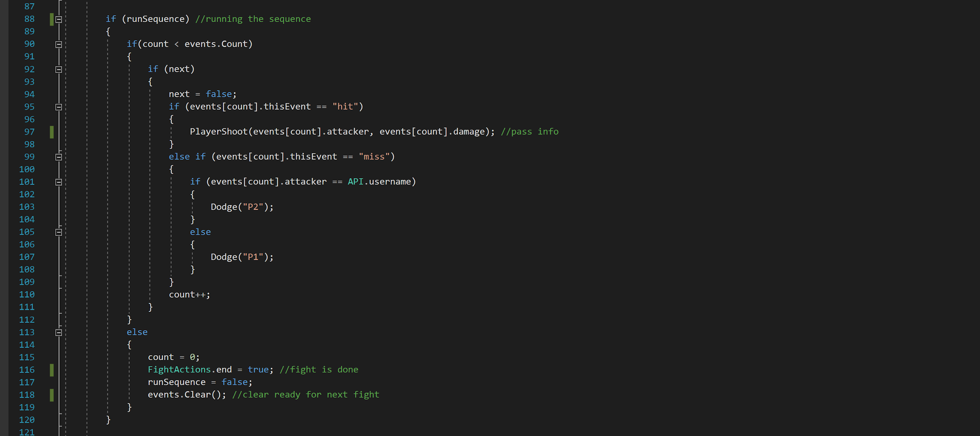

PlayerShoot() and Dodge() can be called from the runsequence section, and both pass information into the FightActions script.

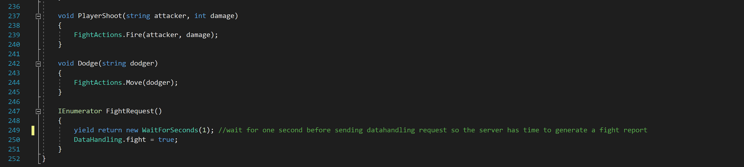

The FightActions script actually handles how the fight looks. The Move() function takes the dodger from FightData and sets getposition to true. It also sets the other cube to fire for visuals sake. Getposition being true means the program saves the current position of the cube that’s dodging to refer to later, and sets move to true. Move being set to true causes the cube to move to the right until it’s position is 0.58, and then back to its original saved position to look like its dodging.

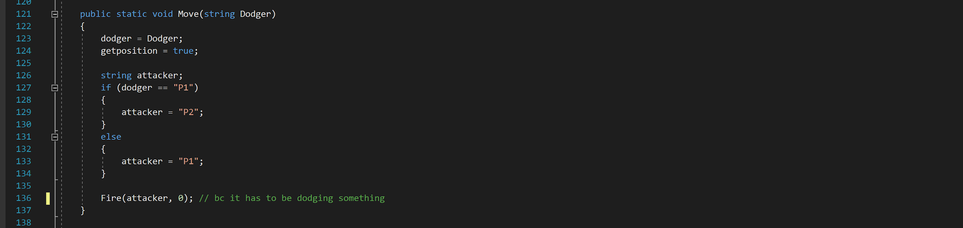

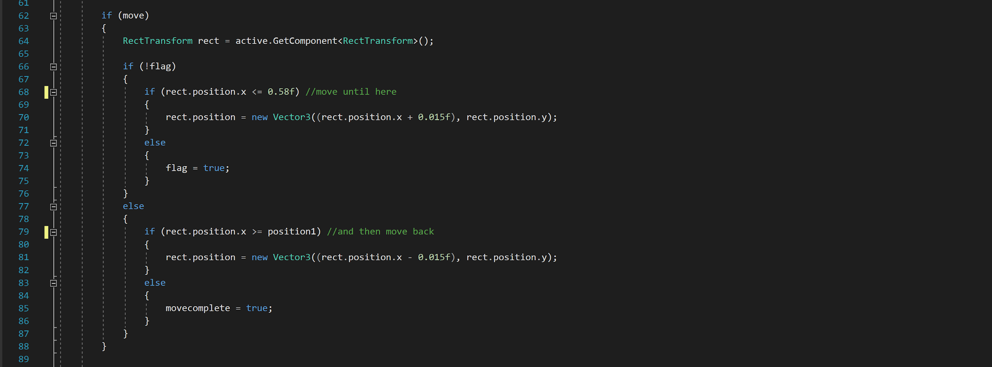

The Fire() function takes the firer and damage from FightData and changes the fire bool to true. This is caught in the Update() and causes a projectile to be instantiated depending on which player is firing.

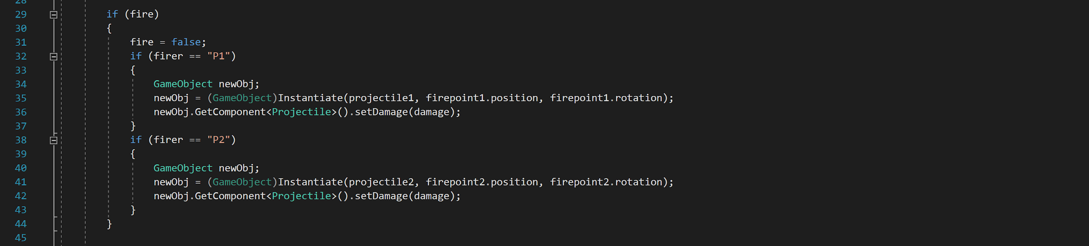

There are two projectile prefabs that look different depending on which cube is firing, but both are attached with a script called Projectile that simply destroys the gameObject when it collides or is out of range and triggers the next instance in events to run. The projectile already has a momentum so it will move as soon as it spawn

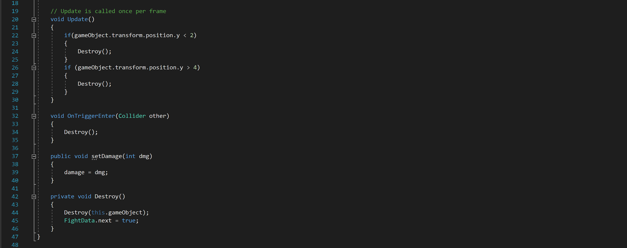

If FightAction’s end is true, depending on the winner, it sets the bool die to true in either the Player1Health or Player2Health scripts. These two scripts are exactly the same but are attached to different cubes, and instantiate a death effect on the cube when die is true.

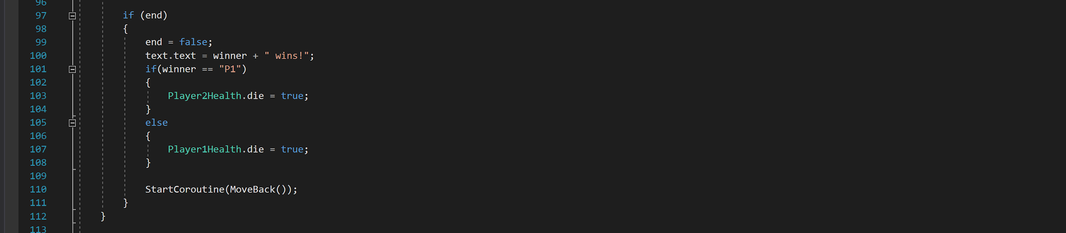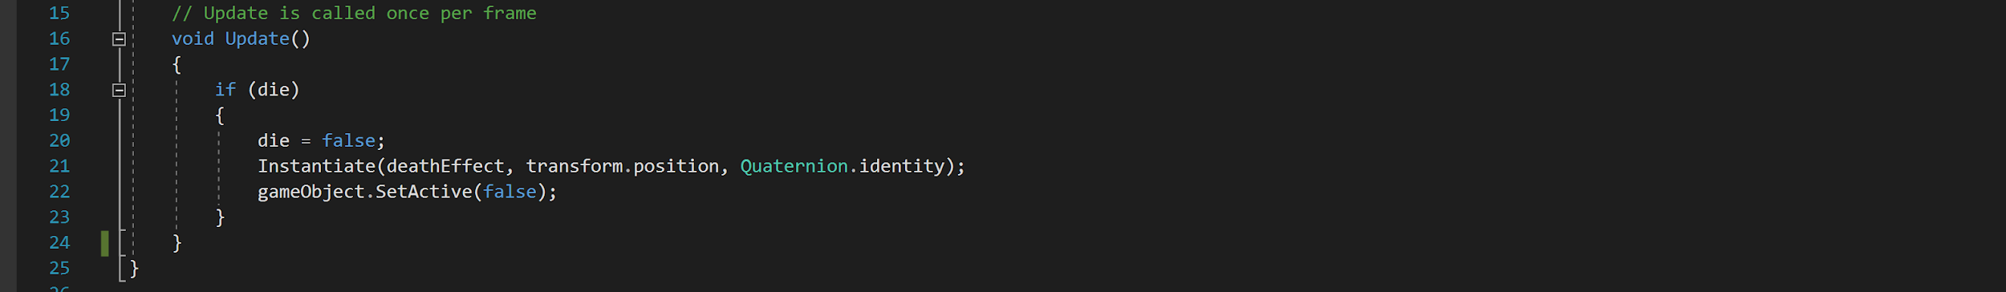

FightAction also displays the winners information and starts a coroutine for MoveBack(). This waits for a couple of seconds before triggering the moveback bool in FightData which returns the canvases to their normal position.

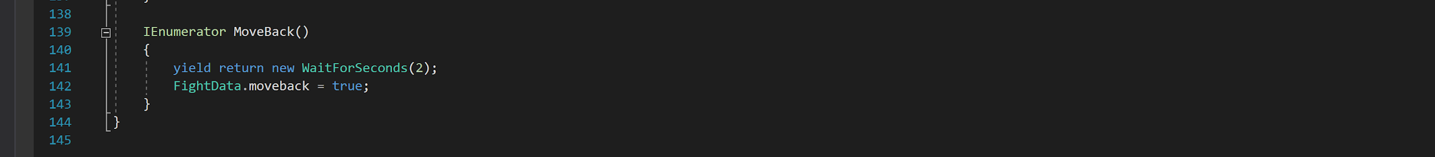

***Back End***

For the back end description I will use the following key: scripts, variables, functions, structs/classes, statements/loops, modules and files. This section is divided into four subheadings for the sake of organisation. A few scripts are ignored as they are simply for debugging purposes.

***Server***

*app.js*

The app.js script is the main script of our entire system, this script manages the whole server and all the requests made into it. This script also runs other scripts from it so we can say that it’s pretty much the brain of the whole operation going on behind back end.

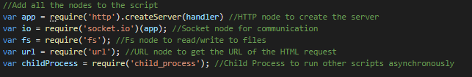

It all starts by loading all the modules necessary for this script, http, socket.io, fs, url and child_process. Http is used to create a web page and host it online (either from a localhost or a remove public ip). Socket.io is used for real time communication between the users (clients connected to the server) and the server, sockets provide all the real time information being displayed on our webpage like the latest requests, the latest leaderboards, etc… Fs is another module used to read and write files, it’s that easy. Url is a module that works together with http so that I can read the URL being requested and send the users in the right direction inside our server. Lastly, child_process is a really important script because it allows the app.js (among others) script to run other scripts while this script is running.

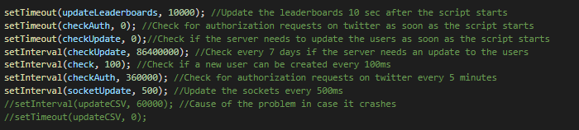

Next we have all the functions that are being used inside app.js. updateLeaderboards, as the name suggests runs a function that then runs another script named Leaderboard.js which then updates all the leaderboards on the game. checkAuth runs another script that checks for authentication requests. checkUpdate checks another script to see if the users need updating or not. Check is used to make sure users get created quickly since it checks for new users in another script every 100ms. socketUpdate is used for updating the data in the website every 500ms.

Now, the main function on this script is the handler one, this function takes care of every single request to the server and makes sure the right things are displayed to the user, among other things.

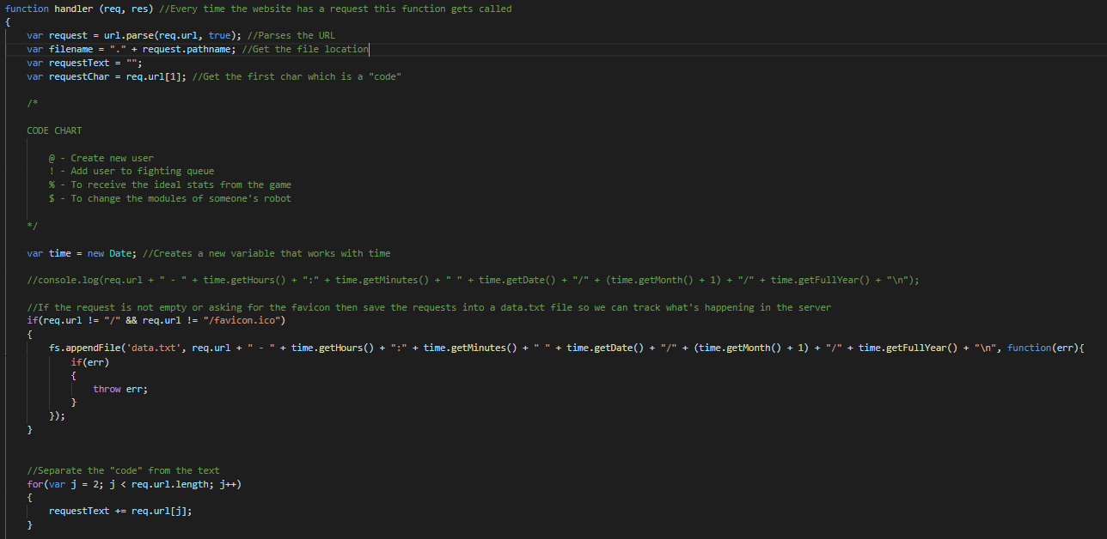

This function takes 2 parameters (req and res) and it’s called every time someone tries to access the website. The first thing it does is to pick up the URL which comes stored in the req variable and then it parses it so it looks more readable to the server. With the syntax we came up with our requests vary depending on what symbol you input in the beginning of the request as we can see in this chart below.

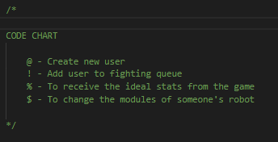

This makes it easy for us to identify what is the intent of the request coming from the game. On the previous screenshot we can also see that everytime someone asks for a request on the server that is not the favicon or the actual index page then it saves that request to a txt file named data.txt for debugging purposes.

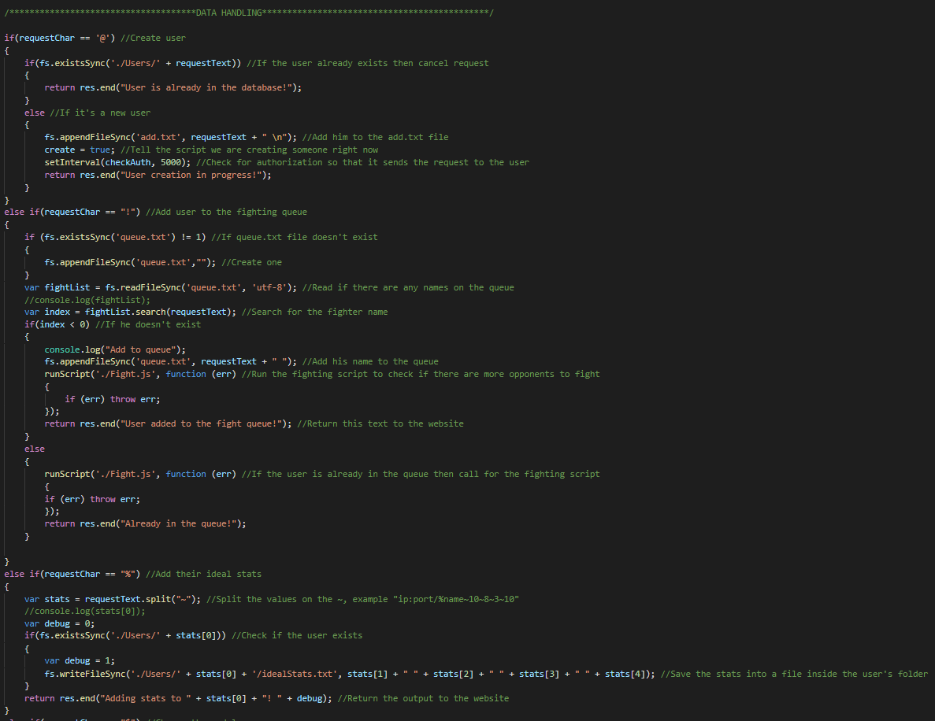

In this chunk of code we can see that there is an if statement that checks if we received any of the actual codes from our own syntax and then if so it does their respective task. When creating a new user, using the “@” syntax what the server does it add their respective name to a txt file named add.txt. After that the check function will detect that there is a new user being created and the CreateProfile.js script will be ran.

Whoever if the app is trying to queue a player into the fighting queue then a request with a “!” must be sent and it will do pretty much the same as the “@” one except that it will add its name into a different txt file named queue.txt.

If the server receives a “%” then it will know it’s for the ideal stats and it’s gonna parse the information and save it on the users folder.

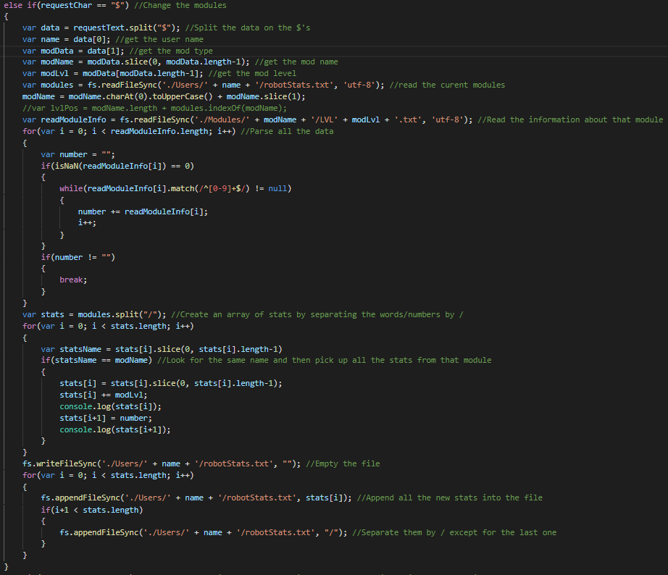

Lastly if the server receives a “$” then it knows it’s time to change the modules of a player.

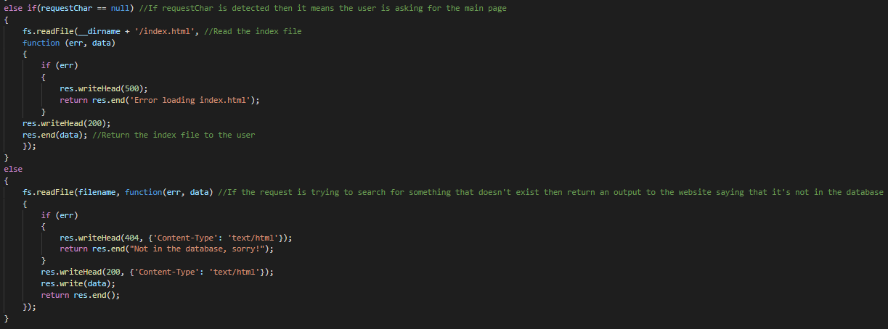

If the server doesn’t receive a special syntax character which is usually the first one to exist after the “/” then it will give back the initial page, the index.html. In case someone sends a wrong request to the server it will display to the user that there is no content like that in the database.

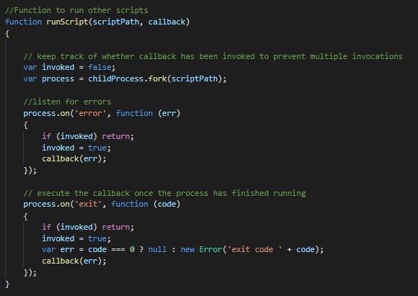

The runScript function is a function that makes use of the child_process node in order to run other scripts asynchronously while the main server keeps running.

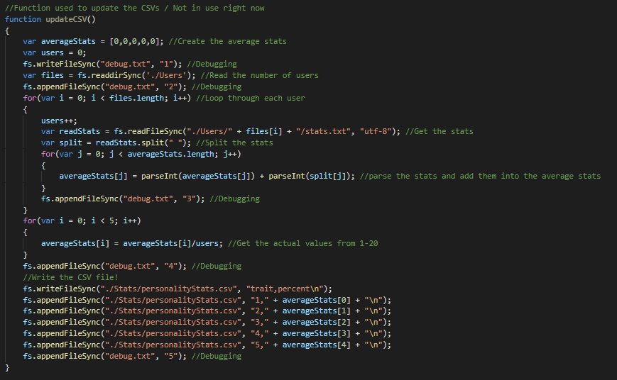

On the updateCSV function which I haven’t spoke about before because it’s not being used at the moment is meant to be used to update all the CSV files that complete the 3 graphs on our website “control panel”. It wasn’t being used because for some unknown bug it was crashing the whole server every couple minutes…

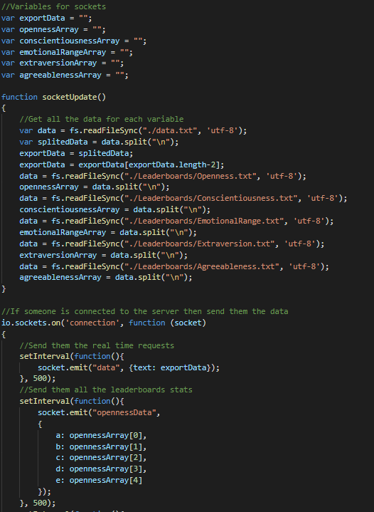

Here’s an example on how sockets work, we would first extract the information into arrays by reading it from the already created leaderboards. Then when a user was connected to the server the sockets would update the information on the graphs every 500ms with whatever was inside the CSV files. Which means that if you changed anything it would change directly on the client side after a couple ms.

***Creating profile***

*CreateProfile.js, Authentication.js*

Gonna start by talking about the CreateProfile.js first, this script is used for adding new users into the database and checking for errors before creating them to ensure that everything works fine after creating the account.

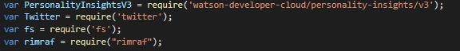

The modules used on this script are the watson-developer-cloud which is used to connect to the watson API and eventually use their personality insight tool. We also make use of the twitter module to connect to the twitter API and get their tweets and information. The fs module I’ve explained before. Rimraf is used to delete whole directories.

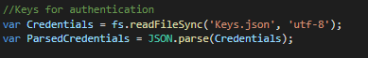

The Credentials variable gets all the secret keys from a json file that can’t be accessed from the server and it’s also not on GitHub and the file looks like this…

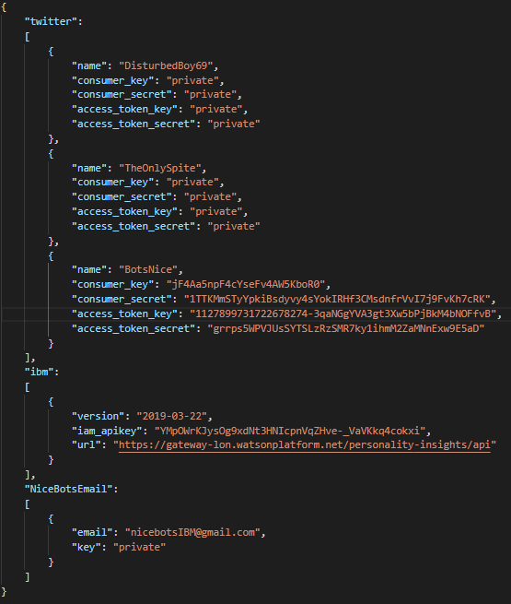

This is where all the keys are stored to be used by the API’s for authentication, the ones that are shown are the ones that we are using for this project.

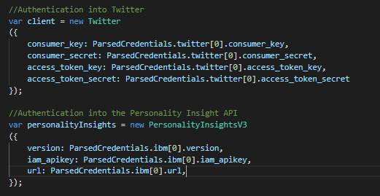

Next we authenticate both twitter and ibm cloud with all my credentials from their websites.

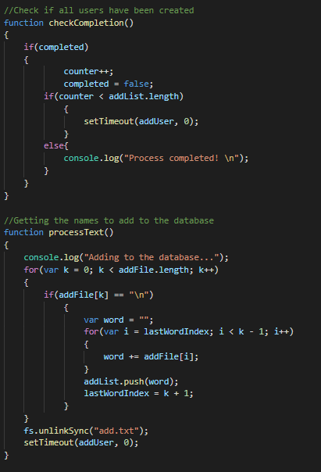

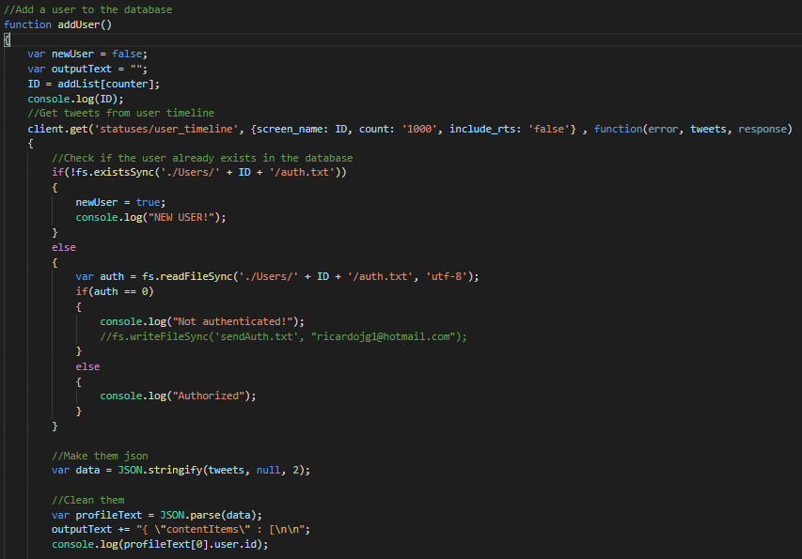

On the function addUser it’s where all the magic happens, the first thing that happens is the server getting all the users from the data.txt. With each user it then sends them into the function addUser and then gets their latest 1000 tweets excluding retweets. With this data we then build a JSON file with all the tweets, organized and ready to send to the watson AI. This is what a profile looks like ready to send.

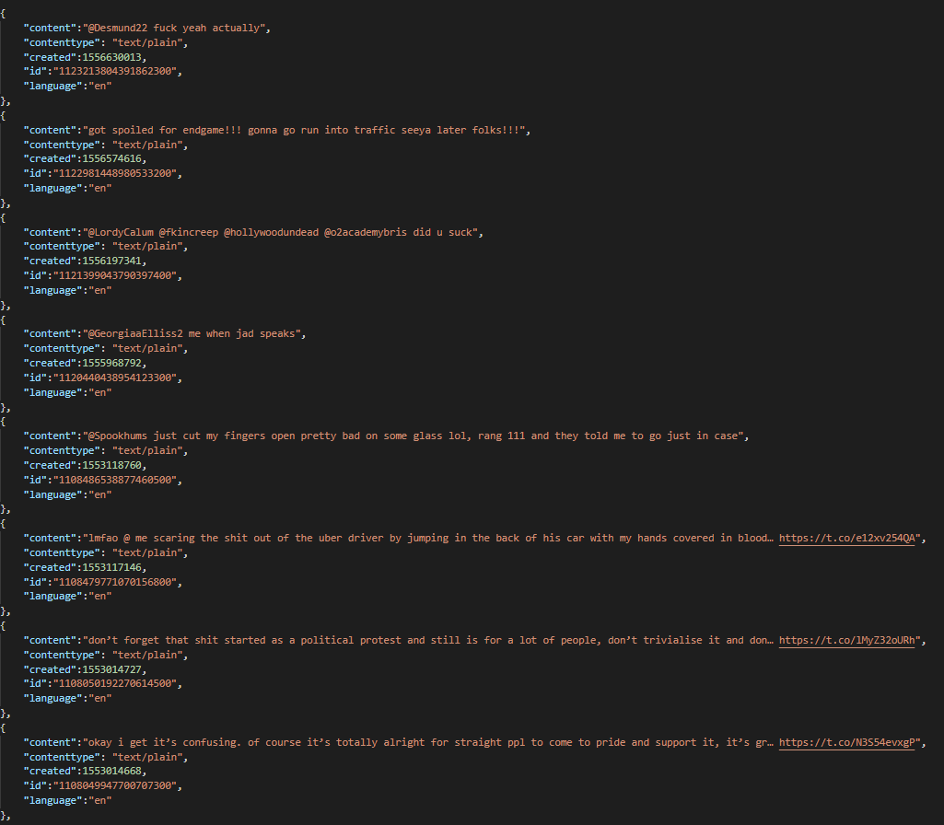

After this file is created it’s stored in the users folder and it’s then sent to the watson AI like we can see in the image below.

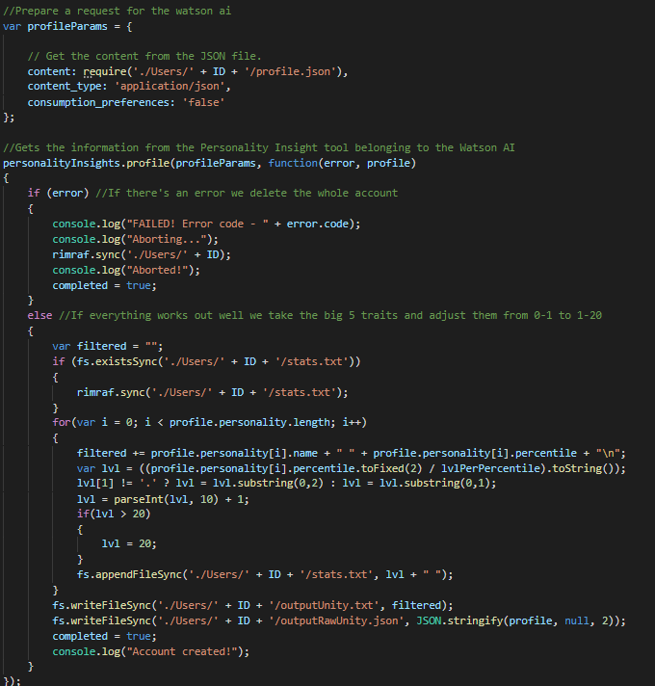

After this process is done the app will send an authorization request to the user’s twitter account asking to confirm it like we can see in the following image.

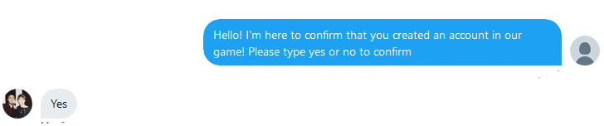

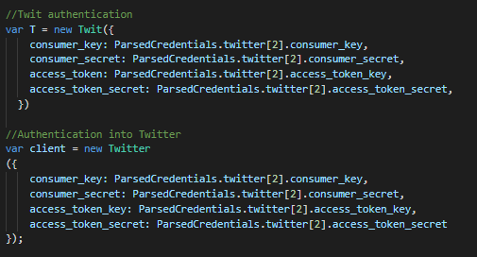

After the user gets confirmed it then enables the user to access the game. So this works by accessing the script Authentication.js, this script takes care of all the authentication part. It all starts by using my credentials to access the API’s. For this script I’ve used both the twitter module and the twit module which is a similar one, the reason why I’ve used two modules for twitter is because I couldn’t get direct messages with the twitter module so I had to use the other one for that.

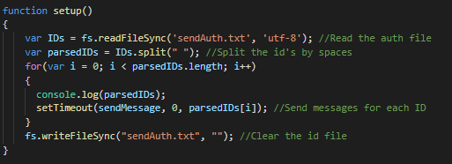

On the setup function we read all the ID’s from the users that need to be authenticated and then pass them into another function called sendMessage.

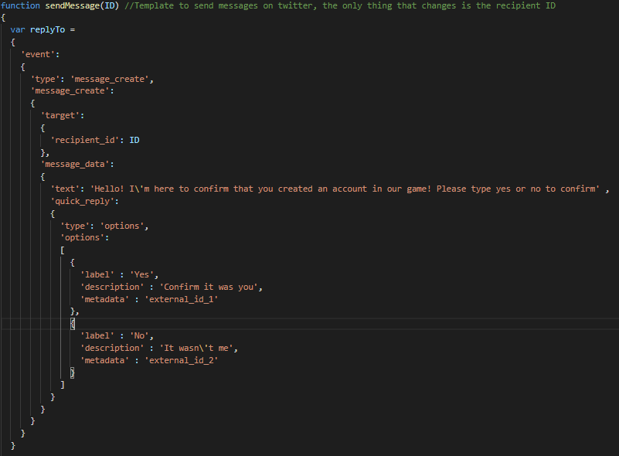

Each ID in the txt file then gets sent a message on Twitter using a JSON format (seen in the image above) and it basically asks the user to confirm or delete the account and it even creates two small options (it’s basically two buttons on the chat) when it sends the text so it’s easier for the user to press yes or no.

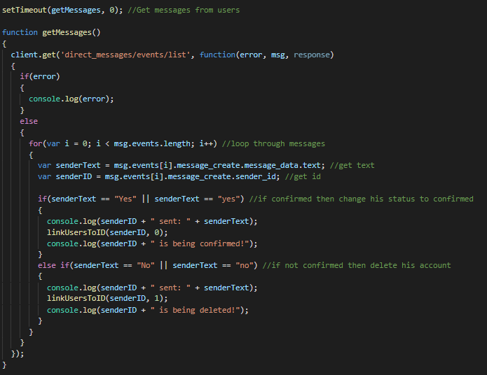

Another function in this script is the getMessages one which pretty much just reads all the messages in the inbox of the bot and then confirms whether or not certain users have confirmed or deleted their account.

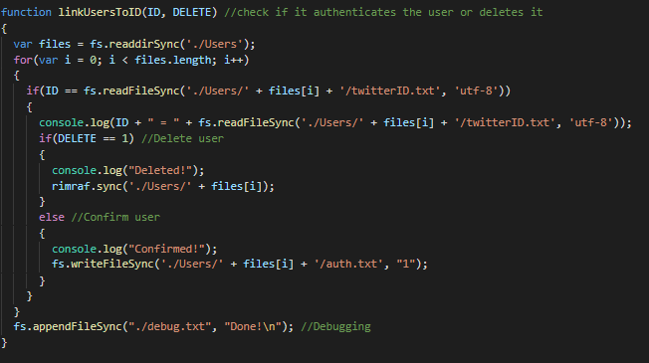

Lastly we have another function named linkUsersToID which picks up the ID’s of the users and connects them to the username and depending on whether the user wants to delete or confirm their account this function handles that side too.

***Updates***

*UpdateWeekly.js, Update.js*

In this game we have an update system that gets the most recent user’s tweets every 7 days. This is created by using 2 scripts, UpdateWeekly.js and Update.js. I’m gonna start by talking about the Update.js which was the first script to come to life, this script was initially made to update all the users without I having to insert them into the system manually one by one all over again.

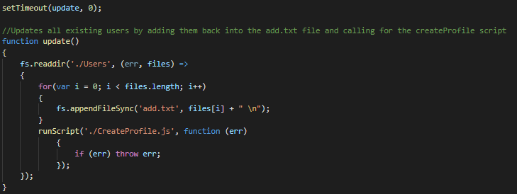

The script is small and quite straightforward, the function update reads all the directories inside the folder “Users” which is where everyone is stored like you can see in the image below.

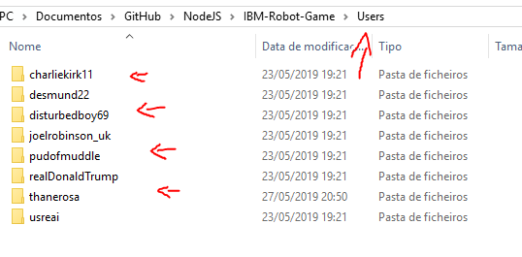

And then it uses the folder names which are their twitter usernames too to save them into the add.txt file we spoke about before, this pretty much adds them back into the system but since they already exist in the system they won’t need to authenticated again and stuff like that, it will just get the most recent tweets and update their personality stats.

So after this script we thought about implementing a weekly update because it would be enough time for people to tweet enough to actually notice changes in the game stats but also because it wouldn’t be too intensive on the API since we only had limited API calls (1000). So this is when we decided to create the UpdateWeekly.js script.

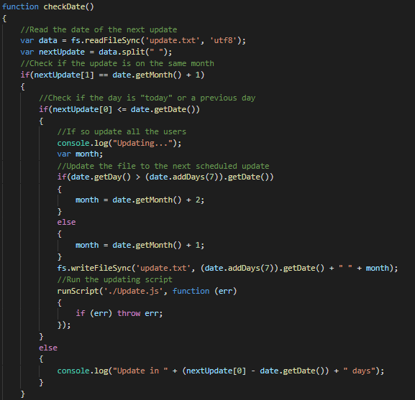

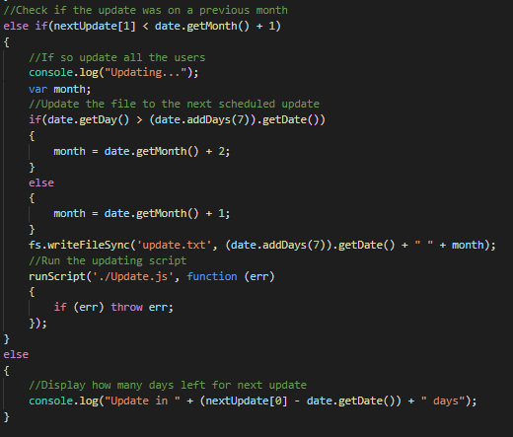

This script as a main function which is the checkDate function, this function pretty much just checks if the current days is after the day that it’s on an update.txt file, if so then it will call the Update.js script and rewrite the update.txt file to be from the current day plus 7 days.

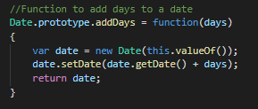

This is another function just to add days to current days.

***Leaderboards***

*Leaderboard.js, CSV files*

Leaderboards is something everyone likes to see when they play a game, being the best in a game is something a lot of people invest a lot of time for, so we decided to create leaderboards too to keep track of which users have the best personality traits. A simple script that would run through every single folder of the Users directory and get all their stats.txt was the plan.

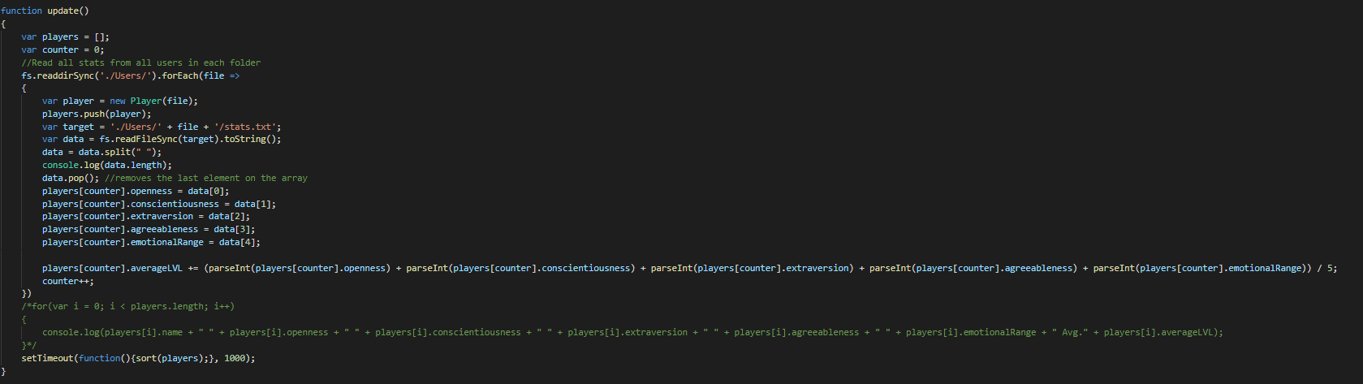

So it starts by organizing the users into an array where it would be easier to work with the numbers and names.

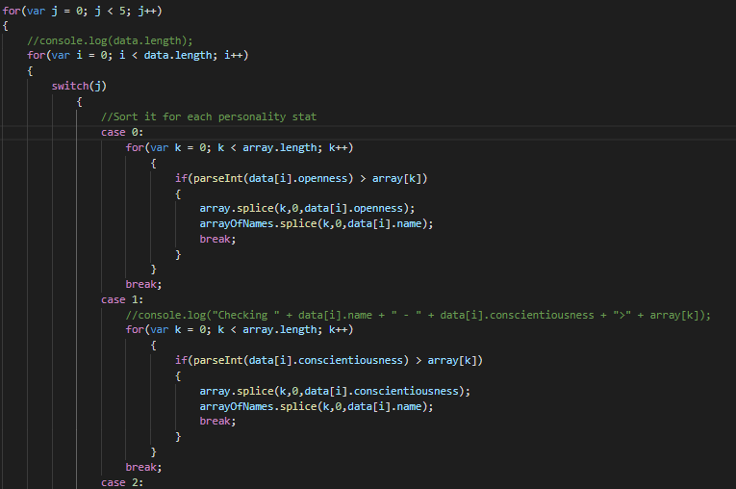

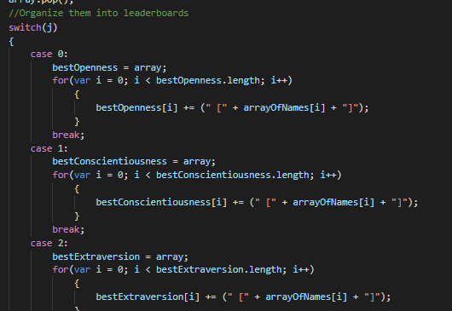

It then sorts them all into arrays with the scores and creates the leaderboards, from the biggest numbers to the smallest ones.

Another thing we were trying to do is to have the CSV files being updated from the leaderboards too as I said before but that script was made a day before the exhibition and it wasn’t fully ready because it kept crashing our server. We still haven’t found the reason why.

***Fighting***

*Fight.js*

The fighting script was a tricky one to make and that’s why it was remade twice. The script would take all the names in the queue.txt file and make pair fight until there was 1 or less people in the queue. To do this the script would pickup the players names and stats and pretty much just compare them to each other and make a “random” fight. The stats were damage, attack speed, evasion and health. The more damage you had the more damage you dealt, the more attack speed the more you shoot, the more evasion the more attacks you can evade and finally the more health the more hits you could stand. The script is well explained in the code so I’m not gonna go into detail too much but I’m gonna show an example of how we picked the players.

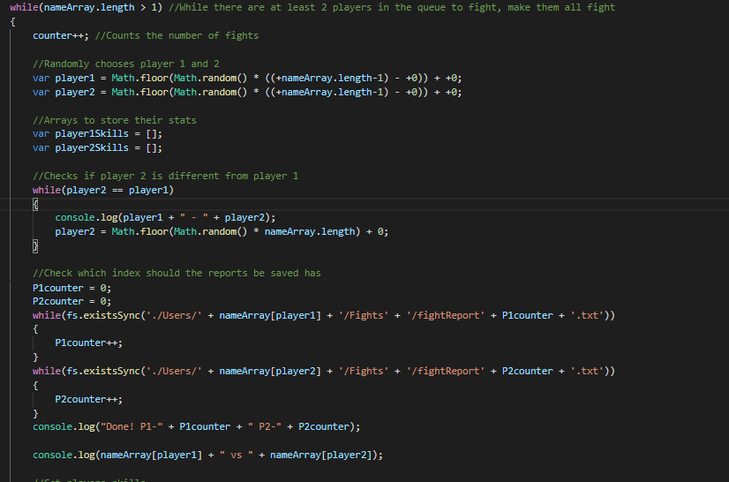

The players would be picked randomly and couldn’t be the same player (obviously?) so the program would check for that too, then it would create arrays to store all their stats and it would also check for the number of the report because all the fighting reports are stored inside the users folder forever.

***Website***

*app.js , main.js,*

When it comes to the website (aka “Control panel”) this was mainly made for entertainment and to attract more viewers in the exhibition because even though it has some utility when it comes to debugging because of the real time knowledge of what was the last request sent to the server it doesn’t really add much into the actual project.

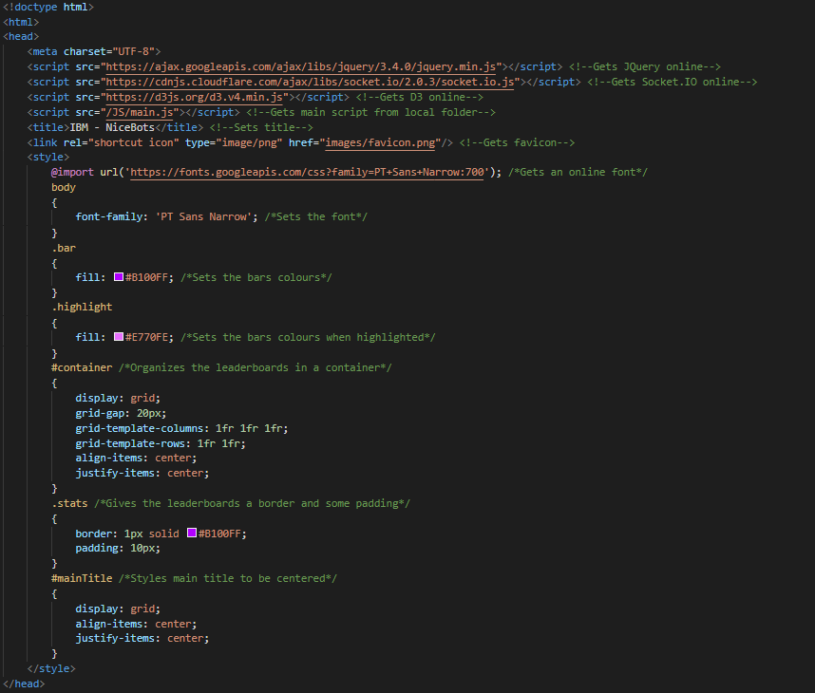

So yeah it all starts with the index.html which had 3 libraries in use, JQuery, Socket.IO and D3 and it also used my script named main.js. It had a title, a favicon and the styling had to be done in the html because I couldn’t manage to make it work with a .css stylesheet in the same folder as the server for some reason?

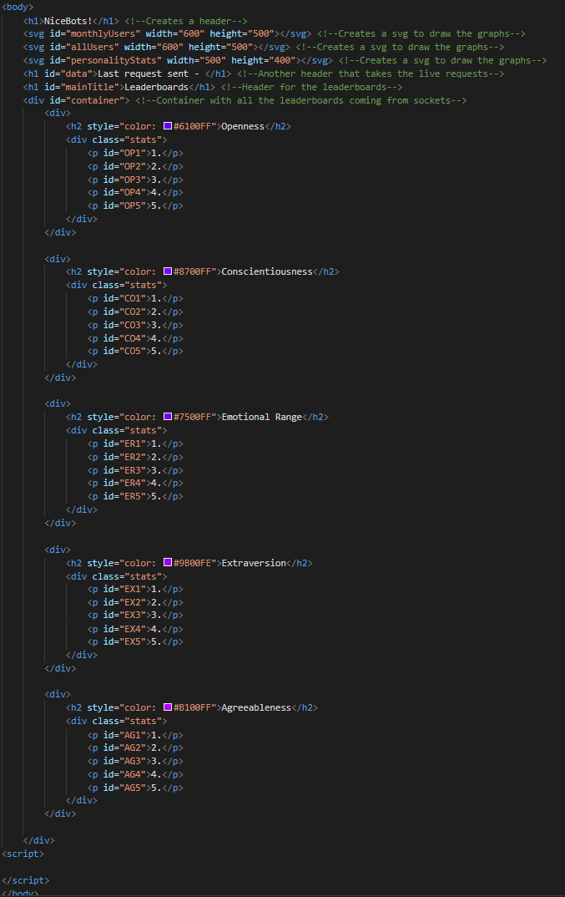

The body was then just the body for the 3 graphs and the 5 leaderboards.

On the main.js is where the magic happens, we have all the functions to draw the graphs and all the sockets to update everything in real time, this is all well explained in the code too so I won’t go into detail.

***Other scripts***

*ChangeModule.js, Email.js, Fight.js, index.html, RunProfile.cmd, RunServer.cmd, Server.js, test.js*

There are some of the other scripts that were used in the production of this project but eventually became obsolete or were upgraded into a better version which we are using now. I won’t go too much into detail on them but I’m gonna give a brief overview of what some of them did.

The ChangeModule.js script was used to change modules when the server would get the request but later on I found that it would be easier ( but less organized, because we were running out of time for the deadline ) to just put the code inside the app.js script instead.

The Email.js script was our first way of authenticating users, by sending them emails but then because of a lot of security problems with Google (deleting our emails, spam, etc) we decided to use Twitter direct messages instead although in my opinion I would say in a long term situation I would have worked a little bit more on the email script to make it functional because I think that’s the best way to go about it and you can also collect emails from the users which is sellable data.

The Fight.js was a really early version of our fighting system, it was a super simple randomized fight that didn’t really used any stats so we eventually had to upgrade it.

Index.html was used to test socket connection only, there wasn't any other purpose for that “script”.

RunProfile.cmd and RunServer.cmd were easy ways of me starting the server instead of having to navigate with the command line through all the directories to get where I wanted to.

Server.js was the earliest version of our server too, it was a lot more messy and disorganized compared to the new version and that’s why we recreated it.

Finally test.js was used to get messages from Twitter and it was the script that made me find out that Twitter module doesn’t work well with getting messages but Twit does. The code was still salvaged and used but the script itself became obsolete.

***Raspberry Pi 3 B+***

We used a raspberry pi 3 B+ as the server and it pretty much works like a computer, we can also access by SSH connection which makes it handy to do remote work on the server from anywhere in the world. There are a couple scripts inside the Pi as well to start everything up on boot up, so even if the Pi turns off for some reason we just need to plug it back in and the server would be up in no time!

The communication between the Pi and the files were made using GitHub, I would code and recreate the server on my local machine and when I saw that things were stable I would commit my changes to GitHub and then pull them from the raspberry pi using SSH. Then a simple reset would apply all the newest changes to the server! The server should be up at this IP <http://2.24.190.83/> , if not feel free to send me an email asking for the current IP!